MG1.1 2nd Exam Units 3+4

Name: Class: mark:
A
- Read the text then answer the followings


ChatGPT is a special computer program that can talk and write like a person. You can type a question, and it will quickly give you an answer. It can also write emails, short stories, or even poems if you ask! ChatGPT is a new kind of Artificial
Intelligence (AI) invention. It helps many people every day. Students use it to learn new things and get help with schoolwork. Business people use it to write fast summaries. It makes our life easier because it can do difficult things to write very fast. It is a powerful tool to help you do more work.
  - What can ChatGPT do like a person?
  - ChatGPT is an old program that cannot write emails. ( True / False )
  - People can use ChatGPT to help with schoolwork. ( True / False )

- Complete the sentences
compact car(s) / opti(on)(s) / appliance(s)
  - I need to buy a new AC and some kitchen .
  - A/An is generally easier to park on crowded city streets.
3) Match each word with its meaning
    - obsolete ( ) money
    - cash ( ) branch of a company ( ) outdated
4) Choose
- Maybe I ( go - will go - am going to go - will going ) to Dammam next week.

- She didn't watch a movie last night, ( she did? - did she? - she didn't? - didn't she? )
- This lesson ( was explain - explained - were explained - was explained ) by our teacher.

- This jacket is ( too small - small too - enough small - enough too ) for me.
5) Correct the underlined errors
  - Ali is the most smart student in the class.

-Mr. Essa Al Hussaini-
Secondary stage
1st mid term
Mega goal 1.1
1447 - 2025

English language
Second semester
Name……………………………………………………………………… Class:……………….
_____________________________________________________________________________________________________________________

2
1. Reading –Q1

London is the capital of the United Kingdom. It is the largest city in Europe. It has held this title for over four hundred years. Over seven million people call London, home. One in ten people, who live in the United Kingdom, live in London. Three hundred fifty thousand people travel each day into London to work. Due to London's location, it is very dry all year. Although it is dry, London is often very cloudy. On average, it rains mildly just about every other day. More than a hundred of the world's major companies have their headquarters in London, making the city a major world influence. Most people from London work in a job that involves printing or publishing.

A) Answer the following questions:
1- How many of the UK's people lives in London? ………………………………………………………………………………………
2- What is the job that people in London work in? ………………………………………………………………………………………

B-choose the correct answer:
1. London, often is very …..
a) warming
b) sunny
c) cloudy
d) windy

2. How many people travel to London to work every day?
a) About seven million
b) About four hundred
c) About three hundred fifty
d) About a hundred
___________________________________________________________________________________________________________________

4
2. GRAMMAR- Q2

A-Do as shown between brackets:
- Sara was late. She missed the bus. (use because)
……………………………………………………………
2- A: I don't want to eat a lot of sugar. ( answer with Neither)
B: …………………………………………………….

B- Choose the correct answer :
- He bought ( his , her ,himself ) a new car.
- I saw ( myself , me ,my ) in the mirror.
- You should ( stay , staying , stays ) .
- You ( must , mustn’t, can) obey and respect your parents .
- She drove ( slow – slows – slowly ).
- Why don't you visit the National Museum? It's ( on – in – off ) the second street.
_____________________________________________________________________________
3-Vocabulary-Q3

4

A-Match each word to its meaning.
1. _____ recover a. unable to move out
2. _____ challenge b. not totally sure
3. _____ guess c. fight against
4. _____ stuck in d. get better

B- Grade the odd word:
- (ankle – eyes – finger -itself) 2- (cut – next to – burn – break)

C- underline the correct word for each picture:

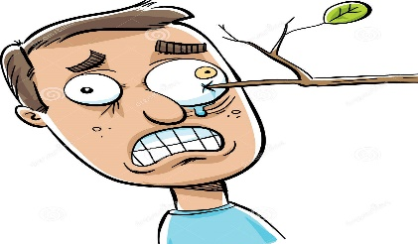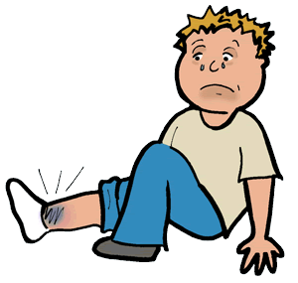

1- (Poke – Break) 2- (Burn – Sprain)

Good luck!
Your Teacher : )
3nd monthly exam
A
Name/…………………………………………………………… class/……………………….

Material is what something is made of. There are 5 bas ic materials. Most things are made with these materials. Some things are made of metal, others are made of glass, wood, cloth, and plastic. There are some other materials, but they are not used as much as these 5 materials. Let’s talk about metal first. Metal is very heavy; it is very hard and strong. It usually feels cool if you touch
it. We use metal to make lots of things. We use it for forks, knives, keys, and cars. We use it for these things because it is very strong.
1/ ………………..is what something is made of .

a/ wood | b/ glass | c/ metal | d/ material
2/ the most important materials are………….

a/ five | b/ fifteen | c/ fifty | d/ forty

Grammar:
3/ it's ………………jacket
a/ hers | b/ mine | c/ her | d/ ours
4/ Rand is …………………than her sister.

a/ tall | b/ taller | c/ tallest | d/ more tall
5/ this perfume …………….like roses.

a/ sound | b/ taste | c/ look | d/ smell
6/ this chair as ………………..as that one.

a/ better | b/ best | c/ good | d/ better than
7/A letter ………………by Ahmad
a/ sent | b/ is send | c/is sent | d/ are sent
8/ I am …………. Young to drive a car.

a/ to | b/ just | c/ enough | d/ too
9/ ……………your book, please?

a/ close | b/ closing | c/ closed | d/ closes
10/ my car is the red…………….

a/ ones | b/ one | c/ two | d/ twice

Vocabulary
a/ smooth | b/ compact | c/ options
A/ Put these words in suitable sentence

11/ it listed all the …………………..that came with the car.

12/ the car would provide a very ……………………ride.

Match
match these words in column ( A) with their meanings in column (B)
A | B
13/ cash in | A) What are you doing now?
14/ revolutionize | B) impossible
15/ what are you up to? | C) greatly change
 | D) to make money

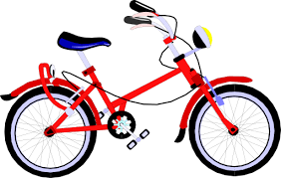
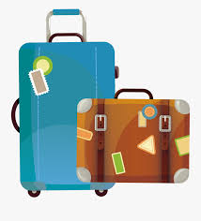
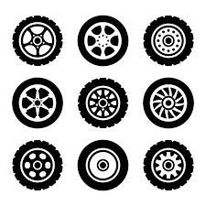
Put each word with suitable picture
a/ bicycle | b/ blacksmith | c/ wheels | d/ suitcase
16 17 18
Optional question:
What does " misjudge " mean?
…………………………………………………………………………………………………………………………………………………………………………………………………………………………………………….

T.Areej AL-Msned

3nd monthly exam
B
Name/…………………………………………………………… class/……………………….

Material is what something is made of. There are 5 basic materials. Most things are made with these materials. Some things are made of metal, others are made of glass, wood, cloth, and plastic. There are some other materials, but they are not used as much as these 5 materials. Let’s talk about metal first. Metal is very heavy; it is very hard and strong. It usually feels cool if you touch
it. We use metal to make lots of things. We use it for forks, knives, keys, and cars. We use it for these things because it is very strong.
1/ the heaviest material is ………………….

a/ wood | b/ water | c/ metal | d/ plastic
2/ one of things we use metal for is…………………

a/ helmets | b/ forks | c/ blankets | d/ pencil

Grammar:
3/ who's book is this? * it's…………….
a/ your | b/ their | c/ her | d/ mine
4/ this building is the …………………in the city

a/ tall | b/ taller | c/ tallest | d/ more tall
5/ this cake …………….like lemon cake, it has the same flavor.

a/ sound | b/ smell | c/ taste | d/ look
6/ this chair as ………………..as that one.

a/ bad | b/ worst | c/ worse | d/ worse than
7/A letter ………………by Ahmad
a/ written | b/ was write | c/was written | d/ are written
8/ this soap is hot ………….

a/ to | b/ just | c/ too | d/ enough
9/ ……………your book, please?

a/ open | b/ opening | c/ opened | d/ opens
10/ my shoes is the red…………….

a/ one | b/ ones | c/ two | d/ twice

Vocabulary
a/ smooth | b/ compact | c/ classic
A/ Put these words in suitable sentence

11/ they said that the car was called a …………and that it would never go out of style.

12/ he wanted to buy a car. He saw a small ……………car that he liked.

Match
match these words in column ( A) with their meanings in column (B)
A | B
13/ franchise | A) What are you doing now?
14/ limited | B) impossible
15/ what are you up to? | C) branch of company
 | D) kept with boundary

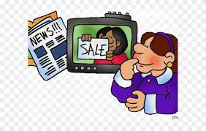
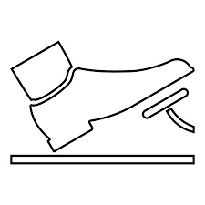
Put each word with suitable picture
a/ advertisement | b/ wheels | c/ bicycle | d/ pedals
16 17 18
Optional question:
What does " weave through" mean?
…………………………………………………………………………………………………………………………………………………………………………………………………………………………………………….

T.Areej AL-Msned

3nd monthly exam
C
Name/…………………………………………………………… class/……………………….

Material is what something is made of. There are 5 basic materials. Most things are made with these materials. Some things are made of metal, others are made of glass, wood, cloth, and plastic. There are some other materials, but they are not used as much as these 5 materials. Let’s talk about metal first. Metal is very heavy; it is very hard and strong. It usually feels cool if you touch
it. We use metal to make lots of things. We use it for forks, knives, keys, and cars. We use it for these things because it is very strong.
1/ the heaviest material is ………………….

a/ wood | b/ water | c/ metal | d/ plastic
2/ one of things we use metal for is…………………

a/ helmets | b/ forks | c/ blankets | d/ pencil

Grammar:
3/ who's car is this? * it's…………….
a/ your | b/ their | c/ her | d/ mine
4/ this project is …………………than math project.

a/ good | b/ better | c/ best | d/ more good
5/ the twin is…………….like their father, they have the same eyes.

a/ sound | b/ taste | c/ look | d/ smell
6/ this chair as ………………..as that one.

a/ expensive | b/ more expensive | c/ most expensive | d/ expensive than
7/A cake………………by my mother.

a/ made | b/ was make | c/was made | d/ are made
8/ this house is big………….

a/ to | b/ just | c/ too | d/ enough
9/ ……………your hand, please?

a/ raise | b/ raising | c/ raised | d/ raises
10/ my bag is the red…………….

a/ ones | b/ one | c/ two | d/ twice

Vocabulary
a/ smooth | b/ compact | c/ classic
A/ Put these words in suitable sentence

11/ they said that the car was called a …………and that it would never go out of style.

12/ he wanted to buy a car. He saw a small ……………car that he liked.

Match
match these words in column ( A) with their meanings in column (B)
A | B
13/ franchise | A) What are you doing now?
14/ limited | B) impossible
15/ what are you up to? | C) branch of company
 | D) kept with boundary

Put each word with suitable picture
a/ advertisement | b/ wheels | c/ bicycle | d/ pedals
16 17 18
Optional question:
What does " meteorite " mean?
…………………………………………………………………………………………………………………………………………………………………………………………………………………………………………….

T.Areej AL-Msned

3nd monthly exam
D
Name/…………………………………………………………… class/……………………….

Material is what something is made of. There are 5 basic materials. Most things are made with these materials. Some things are made of metal, others are made of glass, wood, cloth, and plastic. There are some other materials, but they are not used as much as these 5 materials. Let’s talk about metal first. Metal is very heavy; it is very hard and strong. It usually feels cool if you touch
it. We use metal to make lots of things. We use it for forks, knives, keys, and cars. We use it for these things because it is very strong.
1/ ………………..is what something is made of .

a/ wood | b/ glass | c/ metal | d/ material
2/ the most important materials are………….

a/ five | b/ fifteen | c/ fifty | d/ forty

Grammar:
3/ it's ………………cell phone
a/ hers | b/ mine | c/ your | d/ ours
4/ Rand is …………………than her sister.

a/ smart | b/ smarter | c/ smartest | d/ more smart
5/ this new doorbell …………….like a parrot.

a/ smell | b/ taste | c/ look | d/ sound
6/ this chair not as ………………..as that one.

a/ better | b/ best | c/ good | d/ better than
7/A window………………by Ahmad

a/ broken | b/ has breaks | c/ has been broken | d/ are broken
8/ It's…………. small for me.

a/ to | b/ just | c/ enough | d/ too
9/ ……………to your teacher, please.

a/ listen | b/ listening | c/ listened | d/ listens
10/ You can borrow a book. Which ………do you mean?

a/ ones | b/ one | c/ two | d/ twice

Vocabulary
a/ smooth | b/ compact | c/ options
A/ Put these words in suitable sentence

11/ it listed all the …………………..that came with the car.

12/ the car would provide a very ……………………ride.

Match
match these words in column ( A) with their meanings in column (B)
A | B
13/ cash in | A) What are you doing now?
14/ revolutionize | B) impossible
15/ what are you up to? | C) greatly change
 | D) to make money

Put each word with suitable picture
a/ bicycle | b/ blacksmith | c/ wheels | d/ suitcase
16 17 18
Optional question:
What does " unconscious " mean?
…………………………………………………………………………………………………………………………………………………………………………………………………………………………………………….

T.Areej AL-Msned

