
المملكة العربية السعودية الصف: الثالث الابتدائي
وزارة التعليم الفصل الدراسي: الأول
المدرسة ............................. العام الدراسي 1447 هـ
الزمن: ساعة ونصف
الاختبار النهائي لمادة اللغة الإنجليزية – الصف الثالث الابتدائي – الفصل الدراسي الأول (الدور الأول) لعام 1447 هـ
عزيزتي الطالبة:
- استعيني بالله ثم اجيبي عن الأسئلة
- فضلا تأكدي من كتابة اسمك الرباعي ورقم الجلوس
- الإجابة باللون الأزرق فقط

اسم الطالبة رباعيا
رقم الجلوس: |  | الصف: الثالث الابتدائي | المادة: اللغة الإنجليزية
اليوم: | التاريخ: / 7 / 1447 هـ

المدققة وتوقيعها | المراجعة وتوقيعها | المصححة وتوقيعها | الدرجة كتابة | الدرجة رقما | السؤال
 |  |  | فقط |  | General  Questions
 |  |  | فقط |  | Guided  Composition
 |  |  | فقط |  | Reading  Short Sentence
 |  |  | فقط |  | Grammar
 |  |  | فقط |  | Vocabulary
 |  |  | فقط |  | Orthography
 |  |  | فقط | 40 | المجموع


Kingdom of Saudi Arabia 3rd Elementary Grade
Ministry of Education Time: An hour and a half
……….. Elementary School Number of papers: 3 . Final Exam – First Term – 1447 AH
- General Questions:
/ 7
  - Match the questions with the correct answers:
A |  | B
1. Do you have brothers or sisters? |  | I’d like to try cooking.
2. What activities do you want to try? |  | She is a housewife.
3. How do you spell teacher? |  | Yes, I have 2 sisters and 1 brother.
4. What does your mom do? |  | t – e – a – c – h – e – r
  - Choose the correct answer:
1. Which animal looks like a star?
a- a shark | b- a starfish
2. What time is it?
a- It’s half past four. | b- I go to bed at 9 o’clock.
3. Where do they work?
a- They are engineers. | b- They work in the restaurant.

- Guided Composition:
/ 7
  - Complete the conversation. Use the words from the box.
Ali: Hi. I’m Ali. What’s your ……………..?
Omar: My name’s Omar.
Ali: How ………. are you?
Omar: I’m eleven ……….. old.
Ali: Where do you live?
Omar: I …………. in Jeddah.
Ali: What sports do you like?
Omar: I like ………………
Ali: How do you go to school?
Omar: I go to school by ……………
Ali: Nice to meet you.
Omar: Nice to …………. you, too.

live years name football old meet bus

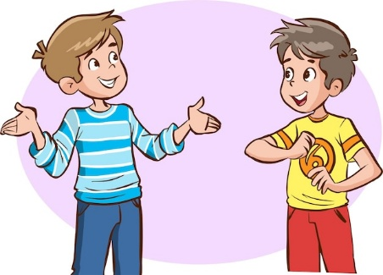

- Reading Short Sentences:
/ 7
  - Read the sentences then match them with the correct pictures:
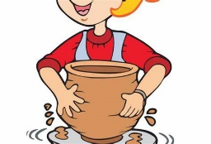 | 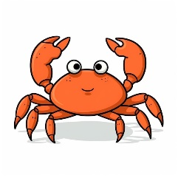 |  | 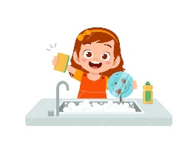 | 
a. I do pottery.  b. I do painting. | a-_It’s a crab.  b-_It’s a dolphin. | a-_It’s a cap.  b-_It’s a coat. | a. I wash the dishes.  b. I fold the laundry. | a. I meet my friend.  b. I brush my teeth.

  - Look at the text and choose the correct option.

    - Ahmed is:
Ahmed is a pilot.
He works in the airport.
He flies airplanes.
      - a doctor.
      - a pilot.
      - a flight attendant.

    - Ahmed works:
a- at school.
b- in the hospital.
c- in the airport.

- Grammar:
/ 7
  - Choose the correct answer:
    - She (has – have – are) a computer.
    - Ali is (tall – taller – tallest than Ahmed.
    - (Do – Does - Is) they play football?
    - He (am – is – are) my father.
    - They (set – sets – setting) the table.
    - Yesterday, I (go – goes – went) to bed at 10 o’clock.
    - A: (Who – Where – What) is she?
B: She is my sister.

- Vocabulary:
/ 7
  - Write the words under the correct pictures:
astronaut – teeth - racket – shirt – bread
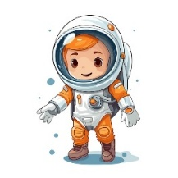
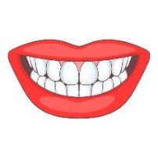 | 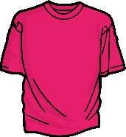 |  | 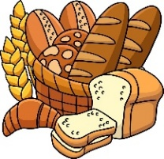 | 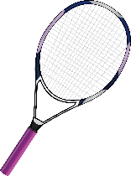

  - Circle the odd word:
1- Sea Animals: seahorse – cat – whale – octopus
2- Jobs: nurse – grandmother – teacher – baker

- Orthography:
/ 5
  - Choose the correct missing letters:
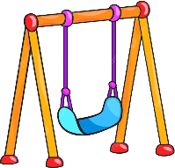  swi__ __ |  | __ __ip |  | 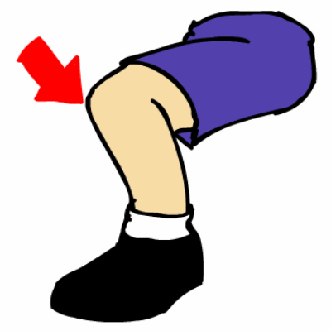  __ __ee |  | 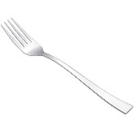  f__ __k |  |   ch__ __se
ng | nk | sh | ch | kn | nk | er | or | ee | oo
  c__ __n |  |   c__ __ |  | 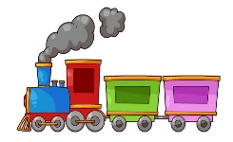  tr__ __n |  | 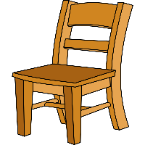  ch__ __ __ |  |   b__ __t
oi | oy | ou | ow | ea | ai | ere | air | oa | ou

END OF QUESTIONS
BEST OF LUCK
Ms. Tahani AlGhamdi

Term: First |  | Kingdom of Saudi Arabia
Year: 1447A H |  | Ministry of Education
Papers No: 3 |  | Ele. school
Time: One and a half hour |  | English language 3th Grade
Questions No: 6
. Final Exam for the 3rd grade – First Term – 1447 AH
اختبار مادة اللغة الإنجليزية للصف الثالث الابتدائي الدور الأول للفترة الدراسية الأولى للعام الدراسي 1447/1448هـ
- General Questions:
/ 8
  - Match the questions with the correct answers:
A |  | B
1. Do you have brothers or sisters? |  | I want to try painting.
2. What activities do you want to try? |  | She is a housewife.
3. How do you spell teacher? |  | Yes, I have 2 sisters and 1 brother.
4. What does your mom do? |  | t – e – a – c – h – e – r
  - Choose the correct answer:
1. Which animal looks like a star?
a- a shark | b- a starfish
2. What time is it?
a- It’s 7 o'clock. | b- I go to bed.
3. Where do they work?
a- They are engineers. | b- They work in the restaurant.
4. what chores do you do every day?
a- I play football. | b- I clean up my room everyday.
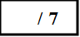
II. controlled writing:
A-rearrange the words to make right sentence:
1- brush -I – teeth – my. ………………………………………………………….
2- feed – I – fish – the …………………………………………………………….
3-playing – He- football – is ……………………………………………………..
4- want – be -to – I – a doctor …………………………………………………….
B-Choose the correct answer:
1- I ………a student. (am – is – are)
2- I………. basketball. (do – is – play)
3- The whale is ……… ( small – big – tiny)
T.O.Cيتبع
( 1 )

III. Reading Short Sentences:
/ 5
A-Read the sentences then match them with the correct pictures:
 |  |  |  | 
a. I do pottery.  b. I do painting. | a-_It’s a crab.  b-_It’s a dolphin. | a-_It’s a cap.  b-_It’s a coat. | a. I wash the dishes.  b. I fold the laundry. | a. Teacher.  b. pilot.
IV. Grammar:
/ 7
  - Choose the correct answer:
    - She (has – have – are) a computer.
    - Ali is (tall – taller – tallest ) than Ahmed.
    - (Do – Does - Is) they play football?
    - He (am – is – are) my father.
    - They (set – sets – setting) the table.
    - Yesterday, I (go – goes – went) to bed at 10 o’clock.
    - A: (Who – Where – What) is she?
B: She is my sister.
V. Vocabulary:
/ 8
A-Write the words under the correct pictures:
astronaut – teeth - starfish – shirt – bread


1- Sea Animals: seahorse – cat – whale – octopus
2- Jobs: nurse – grandmother – teacher – baker
3- Chores: feed the fish – wash the dishes – go shopping - football

B- Circle the odd word:
T.O.Cيتبع
(2)
VI.Orthography:
/ 5
- Choose the correct missing letters:
swi__ __ |  | _ __ip |  | __ __ee |  | 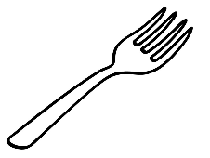  f__ __k |  | ch__ __se
ng | nk | sh | ch | kn | nk | er | or | ee | oo
c__ __n |  | c__ __ |  | tr__ __n |  | ch__ __ __ |  | b__ __t
oi | oy | ou | ow | ea | ai | ere | air | oa | ou

END OF QUESTIONS
انتهت الأسئلة

BEST OF LUCK
Teacher.

(3)

المملكة العربية السعودية  الصف: الثالث الابتدائي
وزارة التعليم الفترة الدراسية الأولى
ابتدائية العام الدراسي ١٤٤٧ هـ
الزمن: ساعتان
اختبار الدور الأول للفترة الدراسية الأولى للعام الدراسي ١٤٤٧\١٤٤٨هـ
عزيزتي الطالبة:
- استعيني بالله ثم اجيبي عن الأسئلة
- فضلا تأكدي من كتابة اسمك الرباعي ورقم الجلوس
- الإجابة باللون الأزرق فقط

اسم الطالبة رباعيا
رقم الجلوس: |  | الصف: الثالث الابتدائي | المادة: اللغة الإنجليزية
اليوم: | التاريخ: / ٧ / ١٤٤٧ هـ

المدققة وتوقيعها | المراجعة وتوقيعها | المصححة وتوقيعها | الدرجة كتابة | الدرجة رقما | السؤال
 |  |  | فقط |  | General  Questions
 |  |  | فقط |  | Guided  Composition
 |  |  | فقط |  | Reading  Short Sentence
 |  |  | فقط |  | Grammar
 |  |  | فقط |  | Vocabulary
 |  |  | فقط |  | Orthography
 |  |  | فقط | ٤٠ | Written exam total

Q1: General Questions:
/7
  - Match the questions with the correct answers:
A |  | B
1. Do you have brothers or sisters? |  | cooking.
2. What activities do you want to try? |  | She is a housewife.
3. How do you spell teacher? |  | Yes, I have 2 sisters and 1 brother.
4. What does your mom do? |  | t – e – a – c – h – e – r

B-Fill in using: ( Jeddah - 9 - Ali )
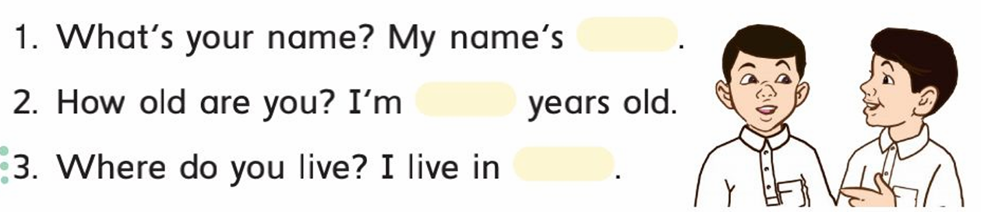

Q2:Guided Composition:
/7
  - Complete the conversation. Use the words from the box.
Ali: Hi. I’m Ali. What’s your ……………..?
Omar: My name’s Omar.
Ali: How ………. are you?
Omar: I’m eleven ……….. old.
Ali: Where do you live?
Omar: I …………. in Jeddah.
Ali: What sports do you like?
Omar: I like ………………
Ali: How do you go to school?
Omar: I go to school by ……………
Ali: Nice to meet you.
Omar: Nice to …………. you, too.

live years name football old meet bus

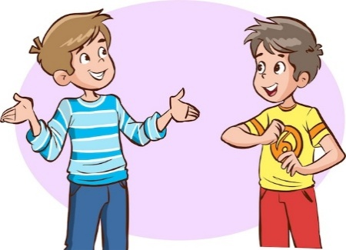

Q3: Reading Short Sentences:
/ 7
  - Read and complete:
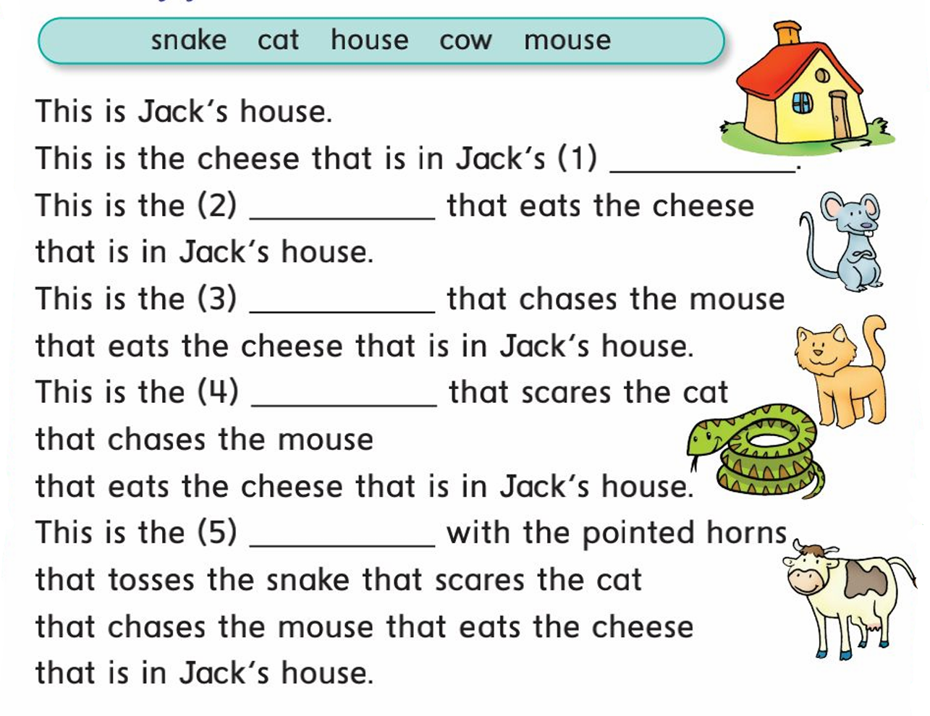

  - Look at the text and choose the correct option.
    - Ahmed is:
Ahmed is a pilot.
He works in the airport.
He flies airplanes.
      - a doctor.
      - a pilot.

    - Ahmed works:
a- at school.
c- in the airport.

Q4:Grammar: Fill in with have-has:
/ 7
- Fill in with have-has: | - Fill in with wash-washes
1-I ………… a b  2-You ………. an i  3-He ……….. a c  4-She ………… a y  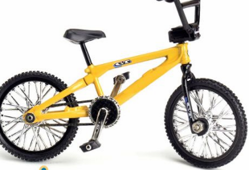 | 1-I ………… the dishes  2-You ………….. the dishes  3-He …………….. the dishes  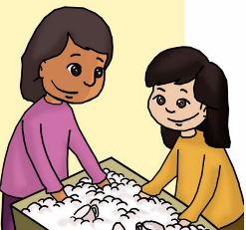

Q5: Vocabulary: Write the words:
/ 7
Cook - nurse - reporter - astronaut - diver - pilot - engineer
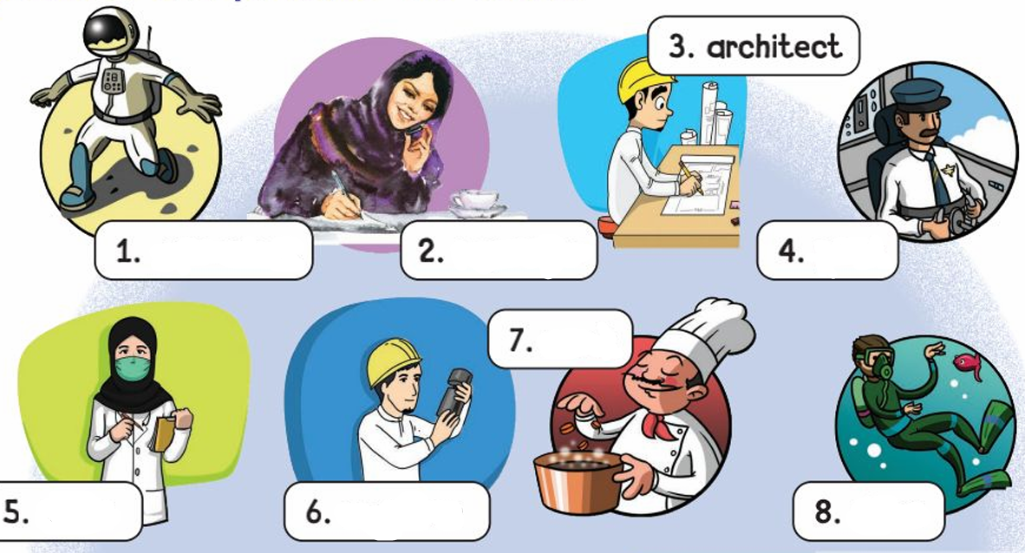
Q6: Orthography. Fill in with: cl \ cr
/ 5
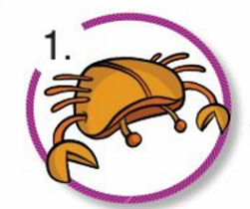  __ __ab | 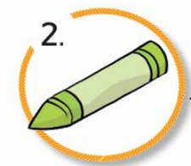  __ __ayon | 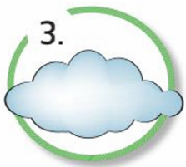  __ __oud | 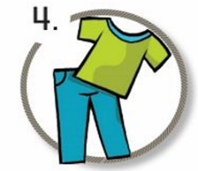  __ __othes | 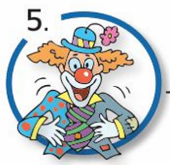  __ __own
END OF QUESTIONS
BEST OF LUCK
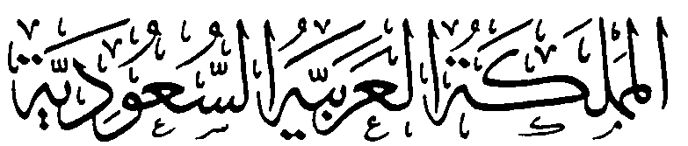  وزارة التعليم  الإدارة العامة للتعليم بمنطقة ...................  مدرسة .............................. |  |    | السؤال | الدرجة |  | اسم المصحح وتوقيعه | اسم المراجع وتوقيعه
 |  |  | السؤال | رقما | كتابة | اسم المصحح وتوقيعه | اسم المراجع وتوقيعه
 |  | الاختبار النهائي للفصل الدراسي الاول  ( الدور الأول )  للعام الدراسي    ١٤٤٧ هـ | الأول
 |  |  | الثاني
التاريخ | / / ١٤٤٧ هـ |  | الثالث
المادة | اللغة الانجليزية |  | الرابع
الزمن | ساعة ونصف |  | الخامس
الصف | الثالث |  | المجموع
اسم الطالب : ............................................................................................. |  |  |  | رقم الجلوس : ............................
- General Questions:

8

- Choose the correct answer:
B | A
( ) I set the table.  ( ) I like tennis.  ( ) I usually get up at 6 o'clock.  ( ) They work in airport.  ( ) I think they're scary.  ( ) Yes, she does sometime.  ( ) I'm 12 years old.  ( ) My dad’s name’s Omar. | 1- Where do they work?  2- What’s your dad’s name?  3- How old are you?  4- What sport do you like?  5- What chores do you do?  6- What do you think about sharks?  7- What time do you get up in the morning?  8- Does she vacuum the floor?

- Controlled Writing: A- Complete the sentences with the correct word:
1 – I think dolphins are ……………..
Golf / fast / teeth / feed / plane
2 – I brush my…………………
3 – I sometimes ………….. the fish.

7

4 – Does your brother play ……………
5 – I'd like to try sky diving but I have no ……………
- Rearrange the words to form a sentence:
- – by - going – am – to -. – school – I – bus
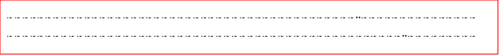
2 – is – lunch – Omar – eating - .
- Reading Short Sentence:
- Read the sentences then choose the correct sentence for each picture:
 |  |  | 
a-_ I think it is scary.  b- I think it is cute.. | a-_ He is cooking.  b- He is watching TV. | a-_ I like skiing.  b- I like basketball. | a-_ My mom is happy.  b- My dad is a doctor .

- Choose  or 

5


1.She washes the dishes. 
2.I want to try tennis. 

- Grammar: A – Choose the correct answer:

7

- I usually ( got – get ) up at 5:00 .
- We ( am – is – are ) superstars.
- Where do you ( work – works – working) ?
- A seahorse is the ( small – smallest ).
- ysterday, I ( come – came ) home at 1:00 .
- ( Do – Does – Are ) he play computer game?
- I ( clean – cleaning ) the room.

- Vocabulary: Choose the correct answer:

8

1 – astronaut 2– rock climbing 3 – nurse 4- jellyfish
5 – shopping 6 – brush my teeth 7 – firefighter 8- walrus

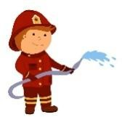

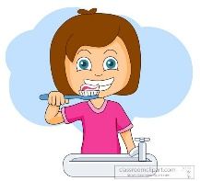
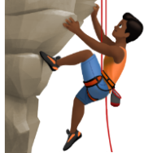





5

- Orthography:
- Choose the correct missing letters:
  pl_ _ |  | 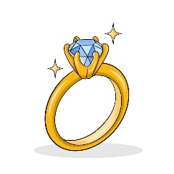  ri_ _ |  |   ni_ _t |  |   sn_ _ |  |   _aker
ay | ai | ng | nk | gh | ph | ow | nu | e | b

