
المملكة العربية السعودية الصف: الثالث متوسط
وزارة التعليم الفصل الدراسي: الأول
المدرسة ............................. العام الدراسي 1447 هـ
الزمن: ساعة ونصف
الاختبار النهائي لمادة اللغة الإنجليزية – الصف الثالث متوسط – الفصل الدراسي الأول (الدور الأول) لعام 1447 هـ
عزيزتي الطالبة:
- استعيني بالله ثم اجيبي عن الأسئلة
- فضلا تأكدي من كتابة اسمك الرباعي ورقم الجلوس
- الإجابة باللون الأزرق فقط

اسم الطالبة رباعيا
رقم الجلوس: |  | الصف: الثالث متوسط | المادة: اللغة الإنجليزية
اليوم: | التاريخ: / / 1447 هـ

المدققة وتوقيعها | المراجعة وتوقيعها | المصححة وتوقيعها | الدرجة كتابة | الدرجة رقما | السؤال
Guided
Composition
 |  |  |  |  | Reading Comprehension
 |  |  |  |  | Grammar
 |  |  |  |  | Vocabulary
 |  |  |  |  | Orthography
 |  |  |  | 40 | المجموع


Kingdom of Saudi Arabia 3rd Intermediate Grade
Ministry of Education Time: An hour and a half
............ Intermediate School Number of papers: 4
Final Exam – First Term - 1447 AH
- Guided Composition:

8
Use the following word bank to write a paragraph about your Important Possessions.
Word bank: (watch – special – like – because – important – year – gift)
________________________
__________________________________________________________________________________________________________________________________________________________________________________________________________________________________________________________________________________________________________________________________________________________________________________________________________________________________________________________________________

9
- Reading Comprehension:
Read the passage and answer the questions below:
Nelly is a nurse. She is tall and thin. She works at the hospital. She looks after sick people. She gets up at six o’clock in the morning. She takes a shower and puts on her clothes. Then, she eats breakfast at half past six. At seven o’clock, she drives her car to the hospital. Nelly starts work at eight o’clock. She cleans the rooms in the hospital. Then, she helps the doctors. At twelve o’clock, she has lunch. She goes home at five o’clock. At home, she takes a shower and cooks dinner. She has dinner at half past six in the evening. Then, she watches TV at ten o’clock. She goes to bed.
- Choose the correct answer:

- Nelly goes to her work ………
- by bus | - on foot | - by car | - by bike
- Nelly has breakfast at ……….
- 6:45 | - 6:30 | - 6:15 | - 6:00
- Nelly has dinner ………….
- at home | - at work | - in the mall | - at restaurant
- look after means:
- see | - take care | - watch | - go
- She in line 5 refers to:
- doctor | - rooms | - Nelly | - sick people

- Check ( T ) or ( F ):

- This text is about Nelly’s daily routine. ( )
- Nelly takes a shower once a day. ( )
- Nelly works for three hours. ( )
- Nelly wears her clothes before breakfast. ( )

9
- Grammar:
- Choose the correct answer:

- Maram usually …….. a haircut every two months.
- Get | - gets | - got | - getting
- Rana and Huda are friends. ……….. of them is a teacher.
- Both | - All | - Neither | - None
- Jana ……. tennis yesterday.
- Play | - plays | - played | - playing
- I am going on vacation ……. August.
- In | - on | - at | - from
- Maybe I …………. early in the morning.
- Leave | - leaves | - will leave | - leaving
- Muslims walk ………... the Kabah.
- Across | - around | - through | - up
- Rateel has lived in New York ……… 2020.
- For | - since | - ago | - yet
- I am studying English ……. I love languages.
- So | - because | - to | - first
- He cut …… yesterday.
- Myself | - herself | - himself | - yourself
- There are …….. monkeys at the zoo.
- a little | - a few | - much | - any

- Do as shown between brackets:

- Is there something I can help you with? (Correct the mistake)
…………………………………….
- Deema visited her uncle last weekend. (Make a Yes/No question)
…………………………………….
- Ruba writes a story. (Change into passive)
…………………………………
- Where is the supermarket? (Make indirect question)
…………………………………

- Vocabulary:

9

- Write the words under the pictures:
condiment – fountain – vaccination – brick – infant – vegetarian
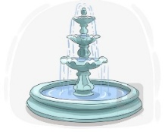
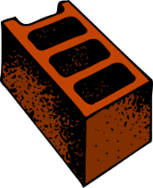



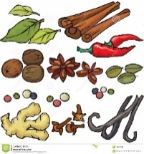

___________ ___________ ___________ ___________ ___________ ___________
- Classify the words:

taxis – watermelon – camera – shrimp – parsley – cheese

Vegetables | Fruit | Dairy Products | Inventions | Vehicle | Seafood
- Choose the correct answer to fill in the blank in each question:

- ‘combination’ means:
- popular | - special | - busy | - mixture
- I want to study ……….. in Canada.
- encourage | - proud | - abroad | - pizza
- I …….. my mailbox every five days.
- check | - leave | - flight | - draw
- I always carry a ………………. computer with me.
- portable | - huge | - big | - enormous
- Circle the odd word:

- grill – rice – fry – steam
- ticket – passport – stranger – boarding pass

- Orthography:

5

- Complete the missing letters:
- She tried her best to sol__e the problem.
- You did an outsta__ding job on the project.
- The city has a warm clim__te.
- Sara needs some lett__ce and tomatoes to make a salad.
- I need a tea__poon to stir my tea.
- I can't answer that puzz__e; I give up.
- Tala had been success__ul at every job she had done.
- Free ticket is availa__le only to students.
- The su__vey questions were not very clear.
- The homeowners decided to reno__ate their old kitchen.

END OF QUESTIONS
BEST OF LUCK
Ms. Tahani AlGhamdi

المملكة العربية السعودية اسم المادة: اللغة الانجليزية
وزارة التعليم الصف: الثاني المتوسط
الإدارة العامة للتعليم بـ ---------- الزمن: ساعة ونصف
مدرسة / -----------------------
أسئلة اختبار مادة اللغة الإنجليزية للصف الثاني المتوسط
الفصل الدراسي (الأول) للعام الدراسي 1447هـ

اسم الطالب: ------------------------------------------- رقم الجلوس: ------------ الصف: --------
ABOKHALEDAMER
0557325813

Total  Written | 5  Orthography | 4  Vocabulary |  | 3  Grammar | 2  Reading Comprehension |  | 1  Guided Composition | Q. NO.
 |  |  |  |  |  |  |  | Mark Given
40 | 5 | 9 |  | 9 | 9 |  | 8 | Mark
Checker: |  |  | Revisor: |  |  | Corrector:

2) Comprehension

9
1- Read the following passage then answer the questions:
Mohamed and his family were in London last week. It was very expensive. They stayed in a hotel for three days. Then they took an apartment. Mohamed stayed there until Friday. He flew back home last night. His father is still there. His mother is with his father. Next week, Mohamed is going somewhere else.

A- Put ( √ ) or ( x ):
1. Mohamed and his family were in Paris. ( )
3. Mohamed flew back home last night. ( )
4. Next month, Mohamed is going somewhere else. ( )

B- Choose the correct answer:
1. He stayed there until (Friday – Saturday – Sunday).
2. Mohamed and his family were in London last (year – week – day).
3. They took an (hotel – apartment – house).

C- Answer the following questions:
1. Where were Mohamed and his family last week? -------------------------------------.
2. How long did they stay in a hotel? -----------------------------------------.
3. Who stayed in London? -----------------------------------------.

1) Composition

8
2- Write a paragraph about “Your Hobby"

You may use these words: painting – drawing – picture – brushes – relaxing - …

--------------------------------------------------

-----------------------------------------------------------------------------------------------------------------------------------------------------------------------------------------------------------------------------------------------------------------------------------------------------------------------------------------------------------------------------------------------------------------------------------------------------------------------------------------------------------------------------------------------------------------------------------------------------------------------------------------------------------------------------------------------------------------------------------------------------------------------------------------------------------------------------------------------------------------------------------------------
3) Grammar

9

3. A: Choose the correct answer:
1. I rarely (drink – drinks – drinking) coffee.
2. I (am – were – was) born in Najran.
3. Maybe I (was – am going to – will) stay with friends.
4. I don’t have (something – nothing – anything) for lunch.
5. Ali is (tall – taller – tallest) than his brother.
B: Do as shown between brackets:
1. How (many) milk do you drink? (Correct)
------------------------------------------------------------------------------------------
3. What – doing – you – are – tonight? (Rearrange)
------------------------------------------------------------------------------------------
4. He is going to travel this year. (Make Yes/No Question)
------------------------------------------------------------------------------------------
5. His parents were (marry) in Tabuk. (Correct the verb)
------------------------------------------------------------------------------------------

9
4) Vocabulary:
4. A- Match the words with the pictures:
Cellphone – tea – suitcases – infants – bullet train

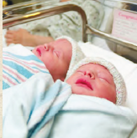
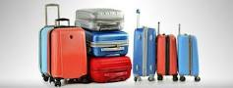
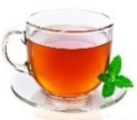
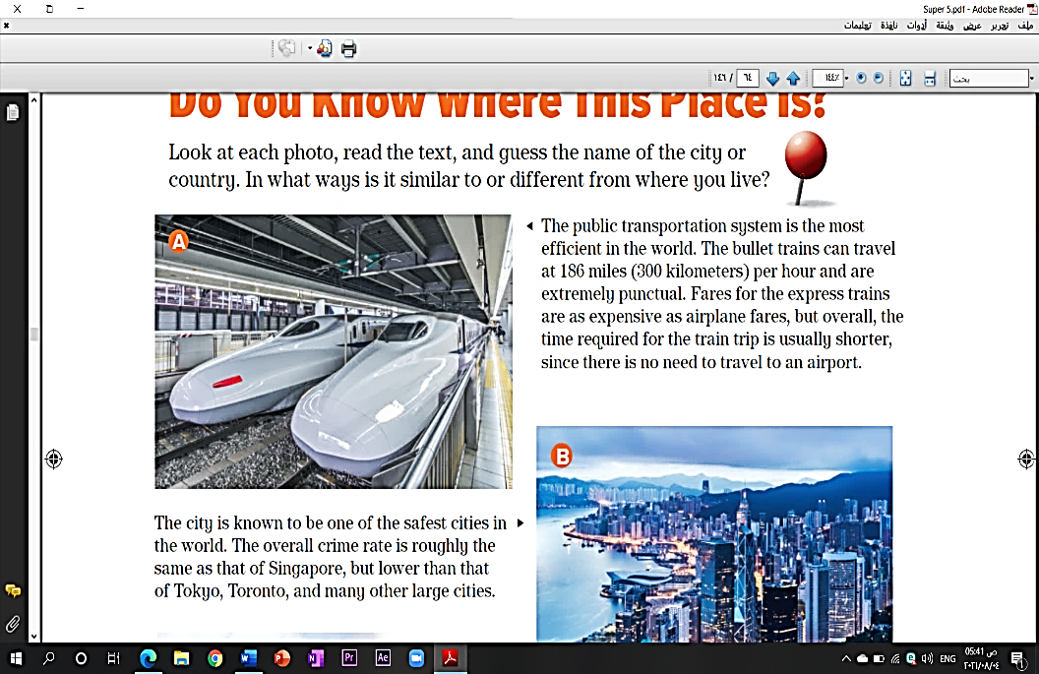

………………………..……. ………………..…….… ……………………...…. …………………....……..

B- Match the answers:
a. in some ways / slightly | 1. a bit | ------
b. a little | 2. kind of | ------
I am very eager for something. | 3. I can’t wait. | ------
d. important opportunity |  | ------

C- Circle the correct spelling:

1. gather - gother – gether
3. tickit – tickete – ticket

5

5) Orthography:

5. A- Fill in the missing letters:

1. add__ct
z – o – i – r – n
2. bl__od
3. airpo__t
4. appeti__er
5. fountai__

B- Choose the odd one out:
1. milk coffee school juice
2. nurse doctor meat dentist
3. always sleep usually sometimes
4. funny What When Where
5. faster wider happier nicest

End of Questions
ABOKHALEDAMER
0557325813

https://t.me/abokhaledamer
Top Goal - YouTube
المملكة العربية السعودية الصف: ثالث متوسط
وزارة التربية و التعليم مادة : اللغة الإنجليزية
المتوسطة ...... بجدة الزمن: ساعة ونصف
أسئلة اختبار الفصل الدراسي الأول للعام 1447هـ
عدد الصفحات : 4 عدد الأسئلة :5

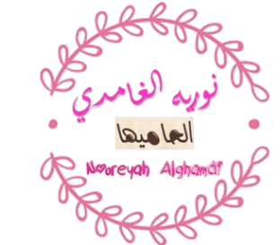
SG3 U1 to 6

++++++++++++++++++++++++++++++++++++++++++++++++++++++++

8
I-Composition: Multiple Choice ( 1- 8 )
1 mark each
Choose the correct answers:

1 | a. laptops | b. televisions | c. phones | d. radios
2 | a. bad | b. happy | c. messy | d. noisy
3 | a. water | b. time | c. energy | d. food
4 | a. heavy | b. harmful | c. helpful | d. hungry
5 | a. museum | b. hotel | c. hospital | d. school
6 | a. tiring | b. difficult | c. harmful | d. exciting
7 | a. playing | b. cooking | c. reading | d. sleeping
8 | a. toddler's | b. youth’s | c. adult's | d. kid's

Using cell 1)……………….. have become among youth's most common 2) …………..habits. They spend 4 to 5 hours a day on their phones, which waste their 3)……………. .Cell phones are 4)………, and they could be used in 5)………….. projects, research reading and communication. On the other hand , they become 6)………… if not used wisely. I think spending too much time on 7)….. and chatting waste 8)………….. time .
_________________________________________________________________

9
II-Comprehension: Multiple Choice (9-13)
1 mark each

Read the passage and answer the questions below:
Four friends—Omar, Samir, Rayan, and Yousef—are planning a fun trip together. Omar is 13 years old and he lives in Abha, and his hobby is photography. Samir is 14 and comes from Jeddah, and he enjoys swimming. Rayan is 15, also from Jeddah, and he likes reading about history. Yousef is 14 and lives in Riyadh, and his hobby is drawing. The friends decide to travel to Al-Ula because it is one of the most beautiful places in Saudi Arabia. They want to see the big mountains, the old historical sites, and the amazing desert views. They will meet on Thursday at 9:00 AM at the main bus station. Omar will travel from Abha by plane to Medina and then take a bus to Al-Ula. Samir and Rayan will travel from Jeddah by train, and Yousef will go from Riyadh by car with his family. All four friends are excited because they will spend two days in Al-Ula exploring, taking photos, drawing the views, learning new things, and enjoying their time together.

1 mark each

Multiple Choice ( 9 - 13 )
Choose the correct answer :
9- He in line (2) refers to…..
d. Rayan |  | c- Omar | b- Yousef | a- Samir
10- Samir is ………………
d. twelve |  | c- sixteen | b- fifteen | a. fourteen
11- Samir and Rayan come from…….
d. Riyadh |  | c- Abha | b- Al-Ula | a- Jeddah
12- Yousef’s hobby is ……..
d. cooking |  | c- drawing | b- reading | a- swimming
13- The boys are travelling to Al-Ula to see the big……...
d. |  | c- trees | b- mountains | a- rivers
True√ \ False x | Put ( T ) or ( F ) (1-4)
T | 1- The boys will meet on Thursday at 9:00 AM.
F |   2- Samer and Rayan will travel by car.
F | 3-Yousef lives in Jeddah.
T | 4-Omar’s hobby is photography.

III-Grammar: Multiple Choice (14-22)

9
1 mark each

14. How often ………………you go to the cinema?
d- do | c- doing | b- does | a- done
15- ………………….. Tom and Peter helped me with my homework.
d- None | c- All | b- Both | - All of
16- She ………………….a simple dress last wedding.
d- wears | c- wear | - worn | - wore
17- I used to ………………….. a lot of coffee.
d- drink | c- drinks | - to drink | - drinking
18- They …………………………… dinner now.
d- cooked | c- are cooking | b-cooks | - to cook
19- I am going to ……………. for a new place to live next month.
d- looks | c- looked | - looking | - look
20. The bus …………………………. at 9 am every day.
d-to leave | c-left | b- leaves | - leaving
21. Bicycles are ………………………. motorbikes.
d- safer | c- safe | b- safer than | a- the safest
22. He has been here …………… 9am.
d- yet | c- already | b- for | a- since

9776
IV-Vocabulary:/Multiple Choice: ( 23 to 28 )
1 mark each
Choose the correct words:

23- The doctor told me to relax and not …………………… it.
d- ignore | c- rush | b- overdo | a- worry
24- She is a TV ………………… and watches as much as she can.
d- addict | c- dislike | b- distaste | a- hatred
25. I enjoy drinking …………………… tea that is made of plants.
d- fizzy | c- herbal | b- spicy | a- fruit
26. They ________ a lot of money.
d- drive | c- fly | b- join | a- donate
27. The ……………………. slept peacefully in the crib.
d- teen | c- adult | b- infant | a- elder
28. The sport teams ………………….. with each other in the cup.
d- run | c- jump | b- compete | a- share
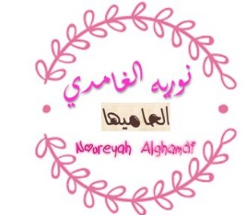
½ each
½ each
Vocabulary: ( 1 to 6 )
Pairing Question:

1 | Bake the cake for 40 minutes. |  | A | to put something into a bag
2 | I seldom go to a library. |  | B | to give a prize
3 | They awarded her a gold medal. |  | C | a substance, such as water
4 | Add a little more liquid to the sauce. |  | D | the opposite of often
5 | I solved the puzzle |  | E | to cook inside an oven
6 | He works out in the gym |  | F | to find an answer to a problem
 |  |  | G | to exercise

576
½ for each
V-Orthography (Spelling): ( 29 to 38 )

29 | To maintain a balanced l__festyle, you should fre__uently stay active.
29 | a. ( o-m ) | b. ( a-r ) | c. ( u-x ) | d. ( i-q )
30 | Fi__ness plays a key role in improving your physic__l health
30 | a. ( t-a ) | b. ( j-u ) | c. ( n-e ) | d. ( l- o)
31 | The n__wborn twins have the same type of b__ood.
31 | a. (u-k) | b. (e-l) | c. (o-s) | d. (a-f)
32 | The principle encoura__ed his empl__yees.
32 | a. ( h-e ) | b. ( b-i ) | c. ( g-o ) | d. ( w-u )
33 | it is sa__ety to have your v__sa with you.
33 | a. (z-u) | b. (x-e) | c. (p-a) | d. (f-i)
34 | The flight de__arture was delayed as a result of fog.
34 | a. ( v-i ) | b. ( c-u ) | c. ( j-a ) | d. ( p-e )
35 | I have enough par__ley and lett__ce for this recipe.
35 | a. (q-o) | b. (s-u) | c. (g-i) | d. (m-a)
36 | I like to eat seafood such as cr__b and sh__imp.
36 | a. (e-p) | b. (o-z) | c. (a-r) | d. (u-v)
37 | This de__ice produces l__ght.
37 | a. ( v-i ) | b. ( k-e ) | c. ( m-u ) | d. ( z-a )
38 | I park my veh__cle near the bri__ge.
38 | a. ( u-j ) | b. ( e-r ) | c. ( a-q ) | d. ( i-d )

END OF QUESTIONS
BEST OF LUCK

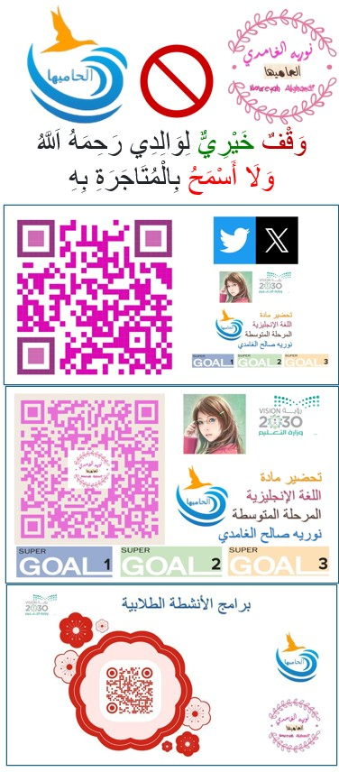
للمعلم والمعلمة لتسهيل العمل
عليهم في العملية التعليمية
إجازة الخريف
الاحد2-6-1447
االاحد23 نوفمبر 2025
من جبال ابها
