

English Language
Intermediate Grade 1st
1st period Exam
……….\20
Kingdom of Saudi Arabia
Ministry of Education
………………… School

Student's Name : class:

……\ 5 marks
1-Read the following passage and answer the questions below:
Omar is a doctor who works at a hospital in Saudi Arabia. He helps sick people every day and always listens carefully to his patients. Omar wears a white coat and works long hours, but he loves his job. He feels happy when his patients feel better and go home smiling.
c- doctor | b- engineer | a- teacher | 1-What is Omar’s job?
c-school | b-hospital | a-museum | 2-Where does Omar work?
c-pants | b- a white coat | a-T-shirt | 3-What does Omar wear at work?
A.Choose the correct answer.
B. C. Put ( ✓ ) or ( ✕ )
1-Omar helps sick people every day. ( ).
2-He feels sad when his patients feel better ( ).

2-Choose the correct answer.
……\ 5 marks

c- don't | b- doesn't | a- am not | 1- I ……..work in school.
c- is | b- has | a- have | 2- Faisal …………a red backpack.
c- driving | b- drives | a- drive | 3- He’s a bus driver. He………. a bus.
c- depressed | b- depressing | a- depress | 4- She is really ……. about the news.
c-doing | b-does | a-do | 5- Nawal is ……….her homework at the moment.

3-Do as shown between brackets.
……\ 2 marks
A. Correct
1- He wants to be a carpenter so he likes to build houses……………
B-(Reorder)
1- Math / quite /a difficult / is / subject
....................................................................................................................................

……\ 4 marks
4- write the correct word under each picture ( excited – carpenter – night – driver )






………………………
………………………
………………………
………………………

……\ 2 marks
5- Choose the correct answer.
1- Members learn lots of computer programs in( computer- science - archaeology) Club.
2- Ahmad’s brother works in a hospital. He’s a (reporter- flight attendant - doctor )
.

……\ 2 marks
6.Choose the missing letter.
1- He has brown eyes and …urly black hair. ( u - c - w)
2- I want to be a pilo… because I’m interested in planes. ( f - t - r )

7- write the missing letter

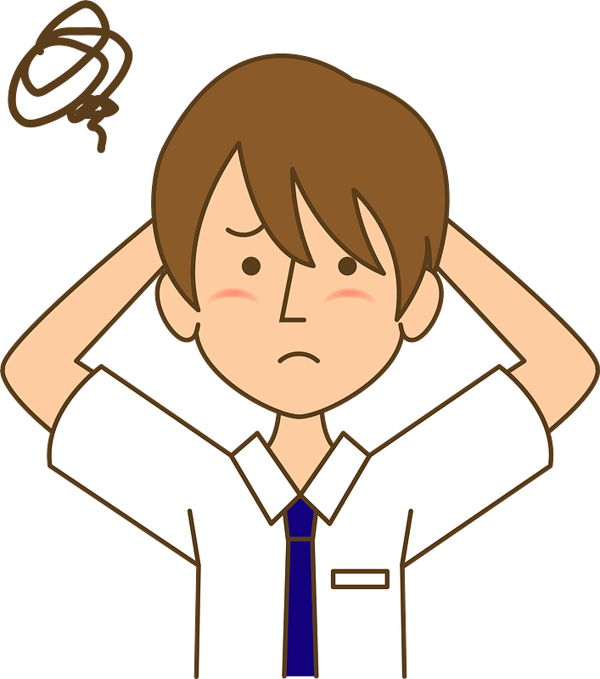

….…hotographer
Bo….…ed



Your teacher:

