Kingdom of Saudi Arabia 4th Elementary Grade
Third Term

10
………….. Elementary School . . Second Quiz – 1447 AH
Name: ………………………………………………………….………………. Class: …………..
- General Questions:
- Choose the correct answer:
1- What’s the matter?
a- I have a stomachache. |  |  |  |  | b- I should go to the hospital.
2- What do you do?
a- I like rabbits. |  |  |  |  | b- I am a vet.
- Controlled Writing:
- Read and write. Use the words in the box:
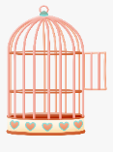  In zoos, some birds often live in this.  ………………. | 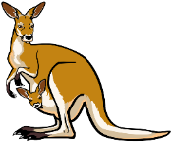  This animal jumps and has big legs.  ………………
kangaroo – stomach – cage
- Reading short sentence:
- Read the sentences then match them with the correct pictures:
 | a-_I put on my clothes.  b-_I take off my clothes.
 | a-_ He has an earache.  b-_ He has a cough.

- Grammar:
- Choose the correct answer:
- I want to ride my bike. You …………. wear a helmet.
- must |  |  |  | - mustn’t |  |  |  | - don’t have to
- Is there …………. to eat? I’m very hungry.
- someone |  |  |  | - nothing |  |  |  | - anything
- It was October …………… I visited Jeddah.
- where |  |  |  | - when |  |  |  | - whose
- The mouse is …………… than the frog.
- fast |  |  |  | - faster |  |  |  | - fastest
- Vocabulary:
- Choose the correct answer:
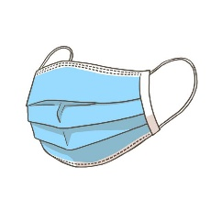 |  |  |  |  | 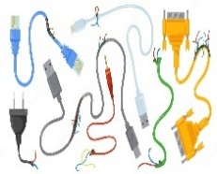 |  |  |  |  | 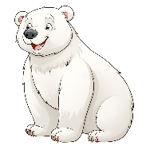
- towel  - mask |  | - band aid  - first aid |  |  | - cables  - toys |  | - pretty  - friendly |  |  | - polar bear  - lion
- Orthography:
- Choose the correct missing letters:
  f__ll |  |   hu__t |  |  |   s__art |  |   bra__e |  |  |   pan__a
a | o | r | n |  | t | m | v |  | f | b | d

BEST OF LUCK
Ms. Tahani Al-Ghamdi
1– How often are you sick?
1
I. CHOOSE
A. I am strong. B. Sometimes .
2– What is your favorite animal?
A. It is cat. B. It is asleep.
المملكة العربية السعودية |  | اسم الطالب/هـ ......................................
إدارة التعليم بمنطقة |  | المادة : انجليزي
مدرسة : |  | الزمن :
مدرسة : |  | الصف : الرابع فصل ( )
شفهي | تحريري | المجموع
10 / | 10 / | 20 /
اختبار الفترة الثانية – الفصل الثاني 1447هـ - الصف الرابع ابتدائي
اسم الطالب / هـ الفصل /

2. CHOOSE OR
1.5

They are in the zoo.
The parrot is in the cage.
The foot got stuck.


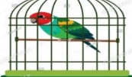



3. CHOOSE TO COMPLETE THE FOLLOWING:
1.5

Do as shown between brackets :

1- cats / the quietest / are / pets. (Rearrange)
………………………………………………………………………………………
2- The same meaning as [ sick ] . ( choose )
A. strong. B. ill

1
shouldn't | Have to | 1- You ________ be quiet in the hospital.
faster | fastest | 2- The horse is …………… than cow .
4. CHOOSE

3
5. Write the correct word:

Polar bear - backache - Vet - ice - interview - frightened

 | 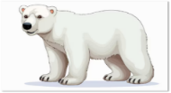 |   هذه الصورة بواسطة كاتب غير معروف مرخصة بالاسم CC BY-NC |  |  | 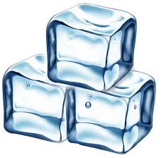  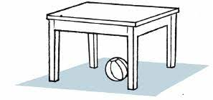

6. CHOOSE THE CORRECT LETTERS:
2

Choose the correct letter:

 | 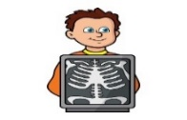 | 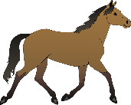 | 
ca_le | X-Ra_ | ho_se | nhappy_
b | e | r | u
f | y | n | o

___________________________________________________________________________________________________________________________________________________________________________________________________________________________________
Controlled writing

4

Good luck T.


المملكة العربية السعودية

الادارة العامة للتعليم بمنطقة ----------------
مدرسة ------------------ الابتدائية
ABOKHALEDAMER
0557325813
Second Term- Second Session Test
Name: ------------------------------------------------------ Grade: 4th
Write the correct number under its picture:
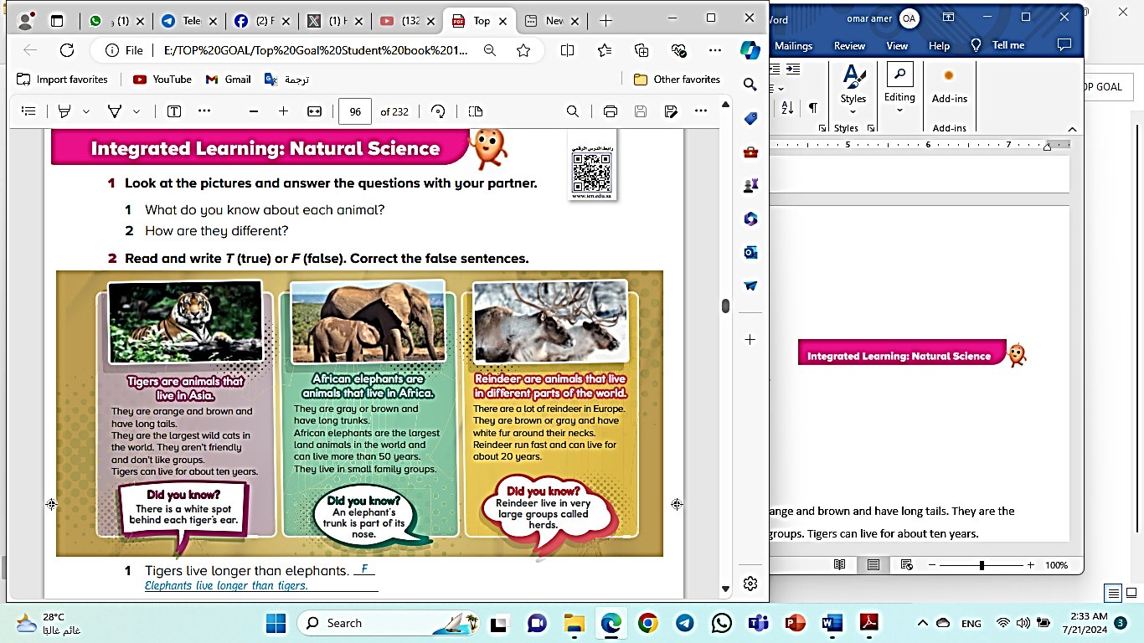
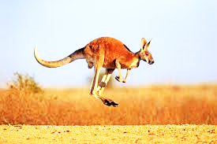
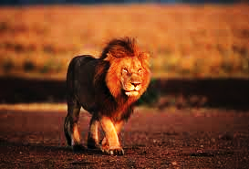
1. elephant 2. slowly 3. lion 4. frightened 5. kangaroo 6. fish
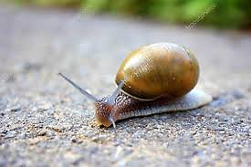


( ) ( ) ( ) ( ) ( )

Match the following:
1. Which animal is running fast?---- | a. quietly
2. That’s the vet who----- | b. than cats
3. Cats walk----- | c. The tiger
4. Horses are more friendly------ | d. works in the zoo.
5. Ali is the oldest in------ | e. my family.

Choose the correct answer: (6 M)
1. This is the cat (that – where – who) had kittens.
2. That is the teacher (who – whose – when) helped the kittens on the street.
3. This is the girl (whose – where – when) horse was in the competition.
4. That is the park (where – who – when) we saw the parrots.
6. This is the day (where – when – who) we help at the animal shelter.
4. Aisha is the (more – many – most) intelligent student who is the in the class.

Rearrange the following sentences: (4 M)
1. Australia – many – animals. – has ------------------------------------------------------
2. the – frighten – Don’t – birds. ------------------------------------------------------
3. than – Kangaroos – are – tigers – taller -----------------------------------------------------
4. are – the – Giraffes – tallest – animals. ------------------------------------------------------

(2) Top Goal - YouTube End of Questions https://t.me/abokhaledamer

