1
1– Do you prefer activities you do outdoors or at home?

A. I like activities. B. I like outdoor activities.
I. CHOOSE
2– What is your favorite way to travel ?
A. By plane . B. I sometimes go to the beach.
 |  | اسم الطالب/هـ ......................................
 |  | المادة : انجليزي
مدرسة : |  | الزمن :
مدرسة : |  | الصف : فصل ( )
شفهي | تحريري | المجموع
10 / | 10 / | 20 /
اختبار الفترة الثانيه – الفصل الثاني 1447هـ - الصف ابتدائي
اسم الطالب / هـ الفصل /

2. CHOOSE OR
1.5

She put on her helmet.
He has a fun trip.
Put everything in a suitcase

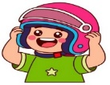

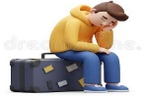
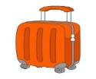

3. CHOOSE TO COMPLETE THE FOLLOWING:
1.5

Do as shown between brackets :

1- yesterday / raining / It / was (Rearrange)
………………………………………………………………………………………
2- __________ To go up in the sky. ( choose )
A. Take off. B. go out

1
was reading | read | 1- Mary ______________ in her tent when I saw her .
have travelled | has travelled | 2- I ______ with my friends.
4. CHOOSE

3
5. Write the correct word:

Taxi - Passport - Sleeping bag - Subway - backpack - Railroad

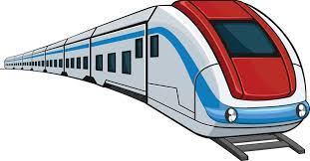 | 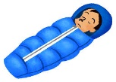 | 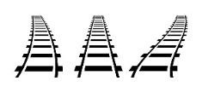 |  | 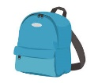 | 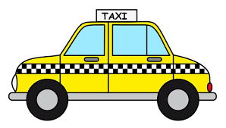  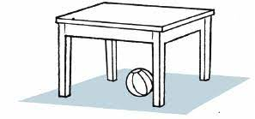

6. CHOOSE THE CORRECT LETTERS:
2

Choose the correct letter:

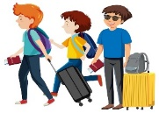 | 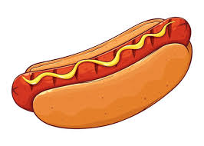 |  | 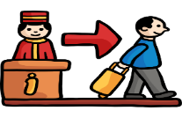
Passen_ er | Hot _og | Statio_ | Check _ut
f | d | n | o
g | b | m | a

___________________________________________________________________________________________________________________________________________________________________________________________________________________________________
Controlled writing

4

Good luck T.

5th & 6th Elementary Grade

10
Second Term
…… Elementary School Second Exam - 1447 AH
Name: ………………………………………………………….………………. Class : …………..
- General Questions:
  - Match the questions with the correct answers:
A | B
1. What items do you need for fishing? |  | We should wear the right equipment.
2. What do you know about being safe outdoors? |  | Go climbing in the mountains.
 |  | I need fishing rod for fishing.
  - Choose the correct answer:
1- Did you have fun on your trip?
a- Yes, I was. | b- Yes, I did.
2- Which activities can make you tired, scared, or bored?
a- playing video games. | b- hiking in the forest.

- Reading Short Sentences:
  - Read the sentences then match them with the correct pictures:
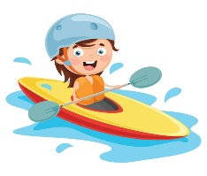 | 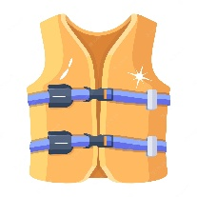 | 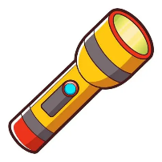 | 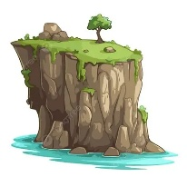
a-_I go surfing on the waves.  b-_I go canoeing on the lake. | a- It is a life jacket.  b- It is a raft. | a- It is a flashlight.  b- It is a surfboard. | a-_That is a cliff.  b-_That is a forest.

- Grammar:
  - Choose the correct answer:
    - She (learn – learned – learning) how to climb yesterday.
    - They didn’t (see – saw – seeing) the snake.
    - We were canoeing (when – while) it started raining.
    - We ate hot dogs while we (sit – sits – were sitting) around the campfire.

- Vocabulary:
  - Write the words under the correct pictures:
horseback riding – thirsty – river – climbing
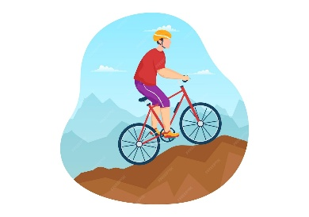
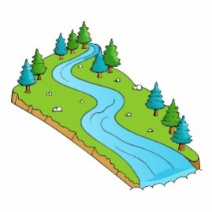 | 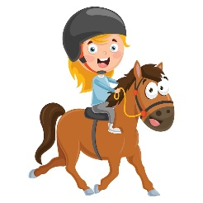 | 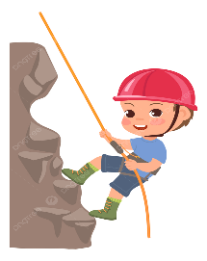 | 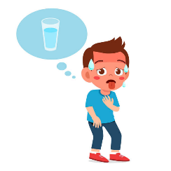

- Orthography:
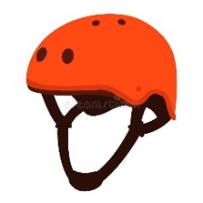  h__lmet |  | 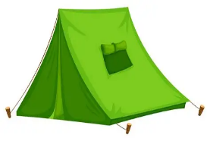  ten__ |  | 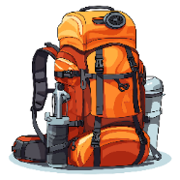  back__ack |  | 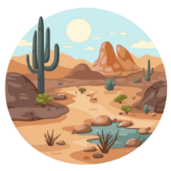  de__ert
i | E | t | b | b | p | z | s
  - Choose the correct missing letters:

BEST OF LUCK
Ms. Tahani Al-Ghamdi

Second Period Exam – Top Goal 2

مدرسة :
الاسم | الفصل | شفهي | تحريري | المجموع
 | / | 10 / | 10 / | 20 /
Choose the correct answer:
/ 1
1– Do you prefer activities you do outdoors or at home?

A. I like activities. B. I like outdoor activities.
2– What is your favorite way to travel ?

A. By plane . B. I sometimes go to the beach.

____________________________________________________________________________________________________
Choose or :
/ 1.5
She put on her helmet. |  | He has a fun trip. | Put everything in a suitcase
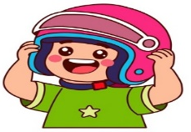 |  | 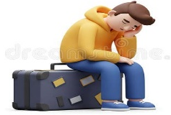 | 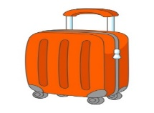
______________________________________________________________________
/ 1.5
1- yesterday / raining / It / was (Rearrange) ………………………………………………………………………………………
Check in | Take off | Go away | 2 –__________ To go up in the sky. choose )
Do as shown between brackets :

Choose the correct word:
/ 1
was reading | read | 1- Mary ______________ in her tent when I saw her .
have travelled | has travelled | 2- I ______ with my friends.

/ 3
Choose the correct word:

Platform | Sleeping bag | Railroad | Suitcase | terminal | Taxi
Subway | hiking boots | Airport | Passport | backpack | Bus
Choose the correct letter to fill in the blank:
/ 2
Passen_ er | Hot _og | Statio_ | Check _ut
f | d | n | o
g | b | m | a

Good luck T.
Controlled writing

4

