1
I. CHOOSE
المملكة العربية السعودية |  |  | اسم الطالب/ ......................................
 |  |  | المادة : انجليزي
 |  |  | الزمن :
 |  |  | الصف : فصل ( )
شفهي | تحريري |  |  | المجموع
10 / | 10 / |  |  | 20 /
اختبار الفترة الأولى للفصل الأول - للعام الدراسي – لغة انجليزية –– للصف ...................
اسم الطالب / هـ الفصل /

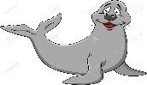
1 – What is that?
A . It's a seahorse. B . It's a seal.
2 – where do you live ?
A. I like some juice. B. I live in Riyadh .

2. CHOOSE OR
1.5

1. He can swim.

This is a computer. .2
3. The whale is small.

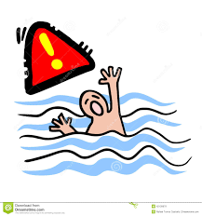




3. DO AS SHOWN BETWEEN BRACKETS
1.5

___________________ |  |  | 1– to - nice – you – meet . ( rearrange )
where | whose | who | 2- ______ skirt is this? It's mine. ( choose )
4. CHOOSE
1

your | my | his | 1 – I am a teacher , _____ name is Nora .
has | as | is | . As fast ___ a dolphin .2

3
4. CHOOSE
starfish - cap - crab

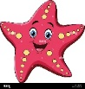 | 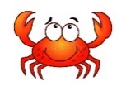 | 


2

Choose the correct letter: ( ai - ea - ow - ee - oa - ou ) )

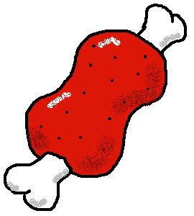 | 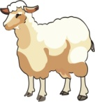 | 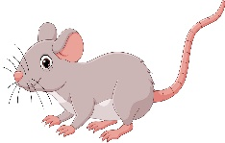 | 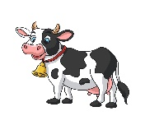
m_ _t | sh_ _ p | m_ _se | c_ _

___________________________________________________________________________________________________________________________________________________________________________________________________________________________________
Controlled writing

4

Good luck
III. DO AS SHOWN BETWEEN BRACKETS

اختبار فتري – الصف الثالث /
الاسم | الفصل | شفهي | تحريري | المجموع
 | / | 10 / | 10 / | 20 /
First Period Exam

1
1. CHOOSE
- What is your name ?
- I am 13 . | - My name is Ali .

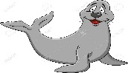

- What is that?
- It's a seal. | - It's a whale.

1.5
222
2. CHOOSE OR

This is a computer. | The whale is small. | This is a dolphin.
 |  | 

1

3. DO AS SHOWN BETWEEN BRACKETS

where | whose | who | 1- ______ skirt is this? It's mine . ( Choose )
slow | scary | fast | 2. Seahorse is ___________ . ( choose)

your | my | his | 1 – I am a teacher , _____ name is Nora .
have | has | is | 2. I _____ a box
4. CHOOSE
1

5. CHOOSE

3

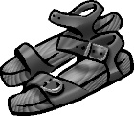 |  | 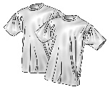 | 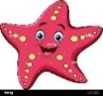 | 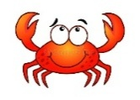  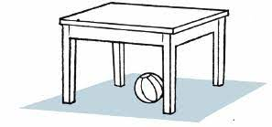 | 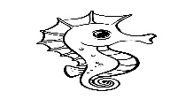
sandals | Thobe | T-shirts | starfish | fish | Seahorse
jacket | cap | Hat | cat | crab | whale

sh_ _ p | 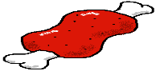  m_ _t | 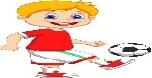  Pl_ _ | 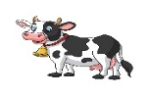  c_ _ | 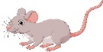  m_ _se
ea | ea | ay | ow | ow
ee | ee | ea | ou | ou
6. CHOOSE THE CORRECT LTTER
2.5

TEACHER :

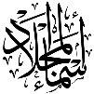
Kingdom of Saudi Arabia

………………… School
English Language
elementary Grade 3rd
period Exam
…………….\20
الاسم: الصف:

……\ 4 marks

General questions

A.Answer the questions
I think whale is fast. |  | Where do you live? | 1
My name is Ali. |  | How old are you? | 2
I am eleven years old. |  | What's your name? | 3
I live in Jeddah. |  | What do you think about whale ? | 4

Controlled Writing
……\ 1 marks
A-reorder.
!- a – It's - walrus

a- It‘s a walrus. b- walrus it's a .

……\ 4 marks

Reading short sentence
 | 1- I am eating cheese.( )
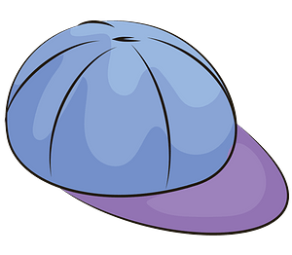 | 2- This is my T-shirt.(
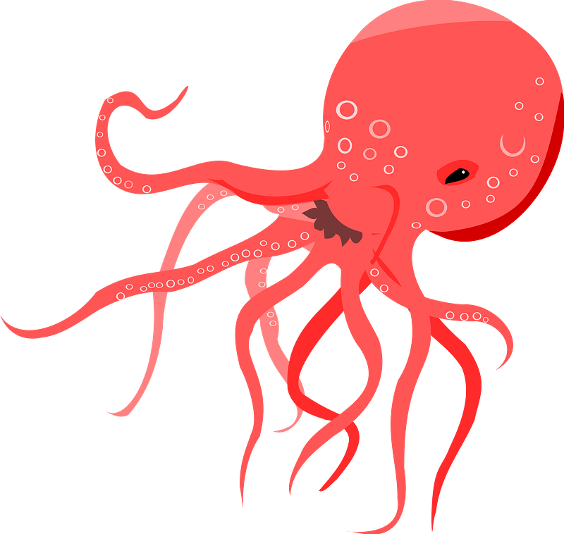 | 3- I think sharks are scary. ( )
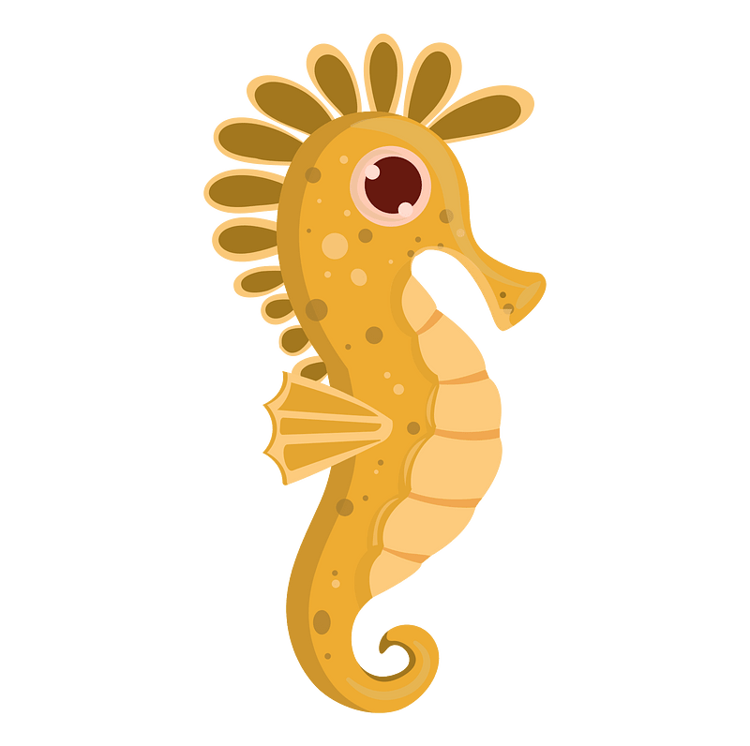 | 4- It's a seahorse ( )
A-Put ( ✔ ) or ( X )

……\ 4 marks

Grammar
A-Choose the correct answer.
c-fastest | b-faster | a-fast | 1- Sharks are ………..than whales.
c-his | b-her | a-our | 2- Omar and …….family live in Riyadh.
c- has | b-have | a- are | 3- She ……….. a new bag.
c- quietest | b- quieter | a- quiet | 4- A polar bear is as ………. as a fish.

Vocabulary

A.Choose the correct word under each picture
……\ 5 marks

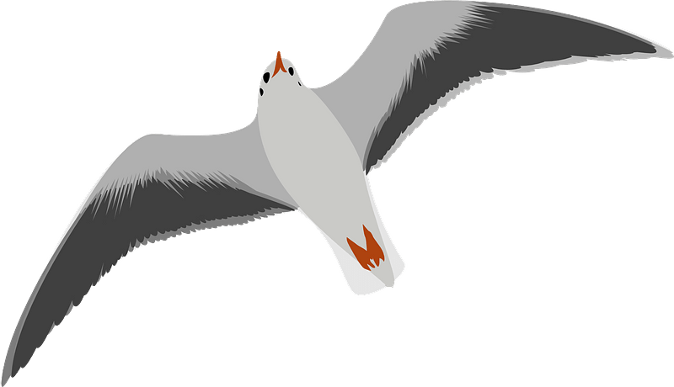 | 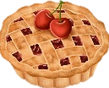 | 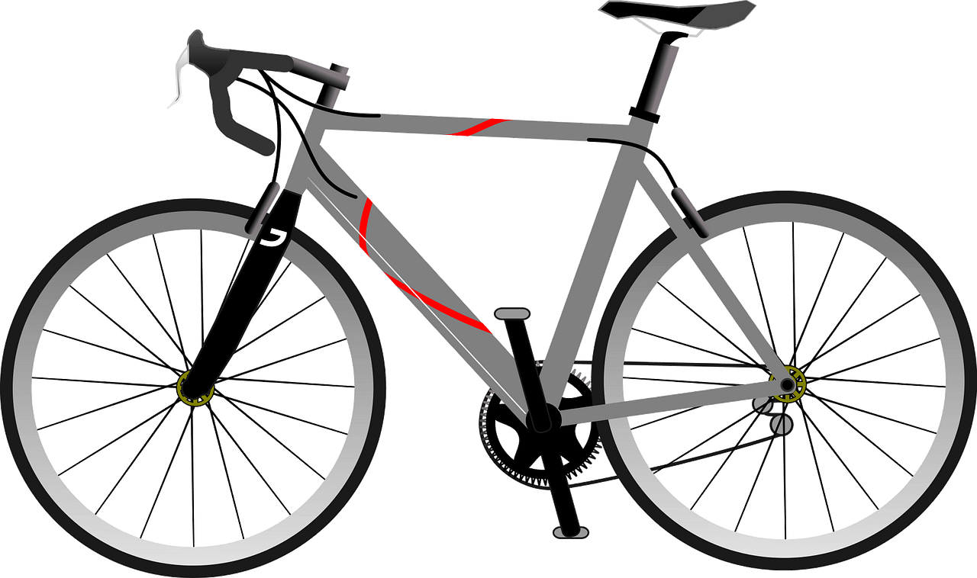 | 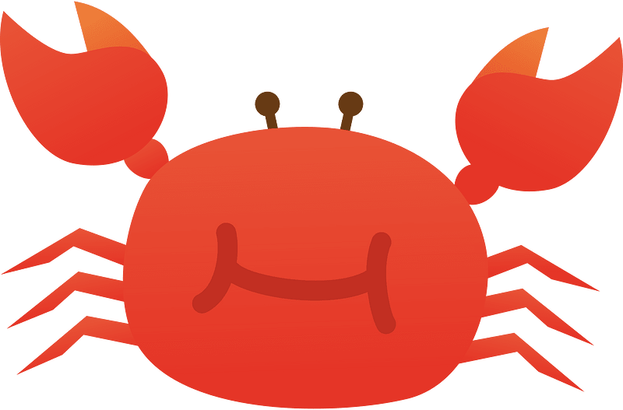 | 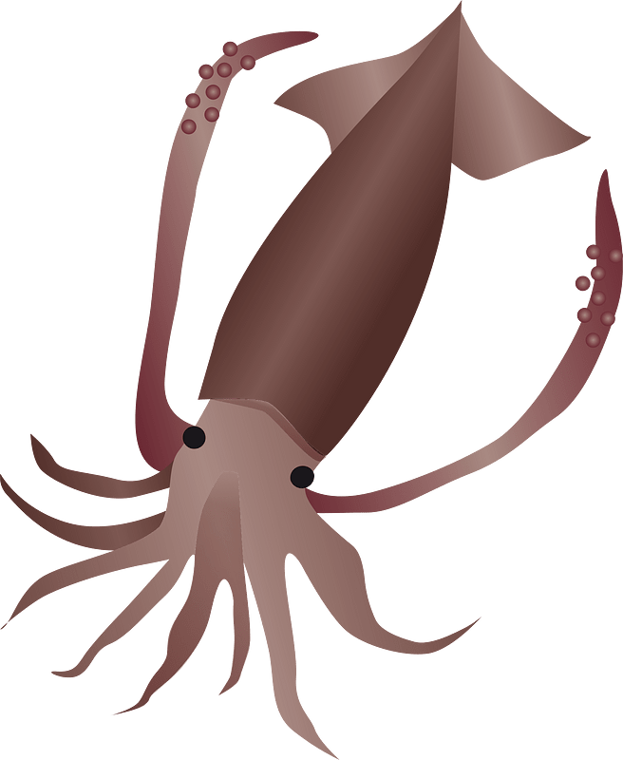
octopus | rice | bicycle | dolphin | squid
seagull | pie | computer | crab | starfish
……\ 2 marks

Orthography
A. Fill in the missing letters

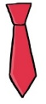
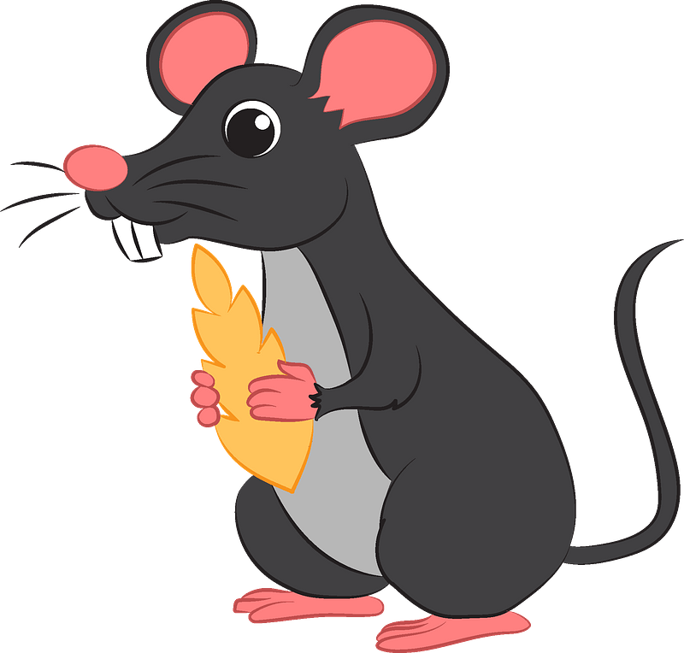
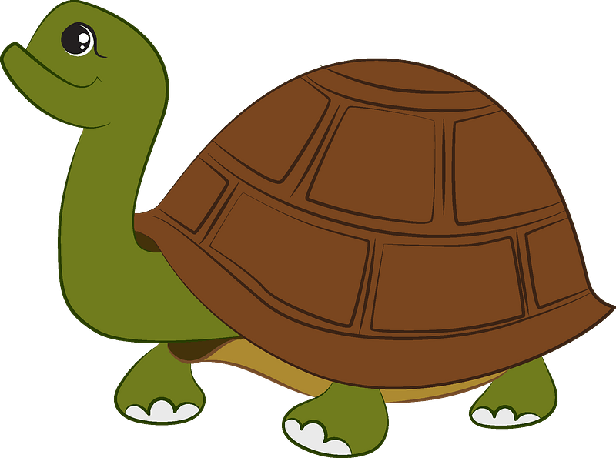
1-m……..se
( bl – kn – ou )
4-r……..n
(bl - ee – ai)
3-t…..…
(kn – ie – cl)

2-….urtle
(f - b - t )

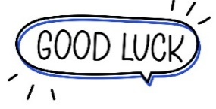
Your teacher:

Your teacher …..:…………………………….

Kingdom of Saudi Arabia Third Elementary Grade
Ministry of Education First Term

10
……………Elementary School . . First Exam - AH
Name: ………………………………………………………….………………. Class : …………..
- General Questions:
- Choose the correct answer:
1- What is your name?
a- My name is Ali. |  |  |  |  |  | b- It is a dolphin.

2- Which animal has 8 legs?
a- It is a cat. |  |  |  |  |  | b- It is an octopus.

3- What is this?
a- It is a dog. |  |  |  |  |  | b- It is a shark.
- Controlled Writing:
- Rearrange the words to form a sentence:
to |  |  | you |  |  | Meet |  |  |  | Nice
- Reading short sentence:
- Read then write the correct number:

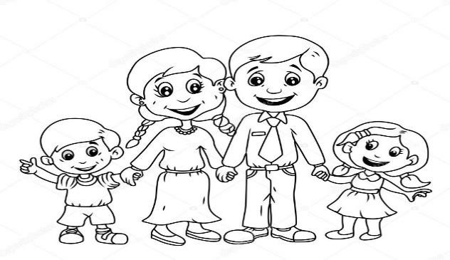

Hello. My name is
Sara
.

1
-

This is my father.

2
-

This is my
sister
.

3
-

This is my
mother
.

4
-

This is my brother.

- Grammar:
- Choose the correct answer:
- They ……… my friends.
- am |  |  |  | - is |  |  |  |  | - are
- This hat is …………
- I |  |  |  | - my |  |  |  |  | - mine
- Ali is ………… than Ahmed.
- tall |  |  |  | - taller |  |  |  |  | - tallest
- Vocabulary:
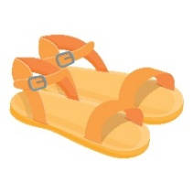
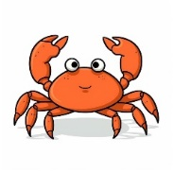
- Choose the correct answer:
 |  |  |  |  |  |  |  |  |  |  | 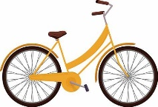
- starfish  - book |  | - sandals  - coat |  |  |  |  | - hat  - crab |  |  |  | - computer  - bicycle
- Orthography:

- Choose the correct missing letters:
pl __ __ |  | 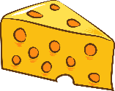  ch __ __ se |  |  |  |  | 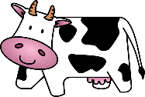  c __ __ |  |  |  | 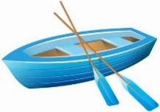  b __ __ t
ay | ow | oo |  |  | ee |  | ow | ie |  |  | ay | oa

BEST OF LUCK
Ms. Tahani Al-Ghamdi

English Language
elementary Grade …..
1st period Exam
…………….\20
Kingdom of Saudi Arabia

………………… School
Student's Name : class:

5

A-Choose the correct answer.

her | my | his | This is our little brother. ……..name is Ahmad. | 1
she | I | mine | Whose shoes are these? - They're ………….. | 2
has | are | have | He …………. a new bag. | 3
cutest | cuter | cute | A dolphin is ………………………... | 4
slowest | slower | slow | A snail is the …………………… | 5

2
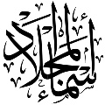
B- reorder.

1- cook \ you \ Can \ ?
………………………………………………………………………………………….………
2- have \ Thay \ a car.
……………………………………………….………………………………………………….

C-Answer the question.
1-what's that ?
3
It's a ( seahorse - fish - sharks ).


2-What are those?
Those are ( crocodile – seagull - baby seals).

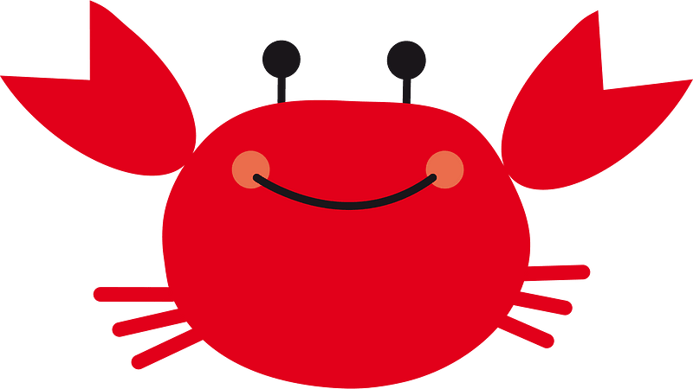
3-What‘s that?
it's a ( squid – crab – Jellyfish ).
2

D.Match
Nice to meet you, too . |  | What's your name? | 1
My name is Ali. |  | Nice to meet you . | 2

4

E. Write the correct words under each picture
Sleep goat rice turtle

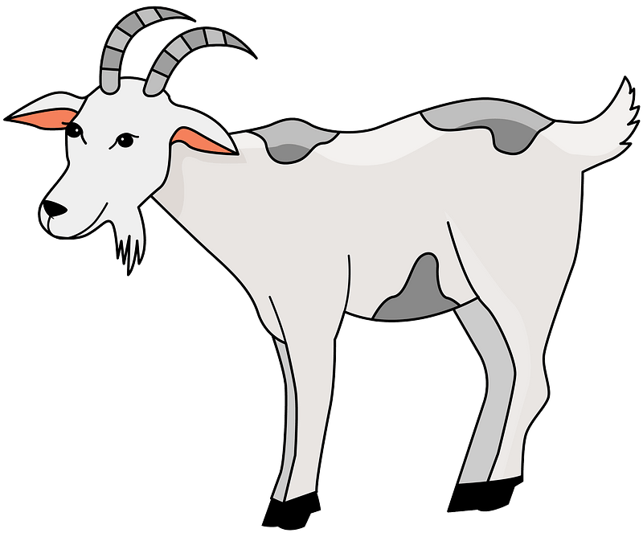


……………………….ر
……………………….ر
……………………….ر
……………………….ر

F.Complete the missing letters.
ee ay ou oa
4


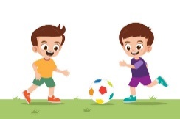
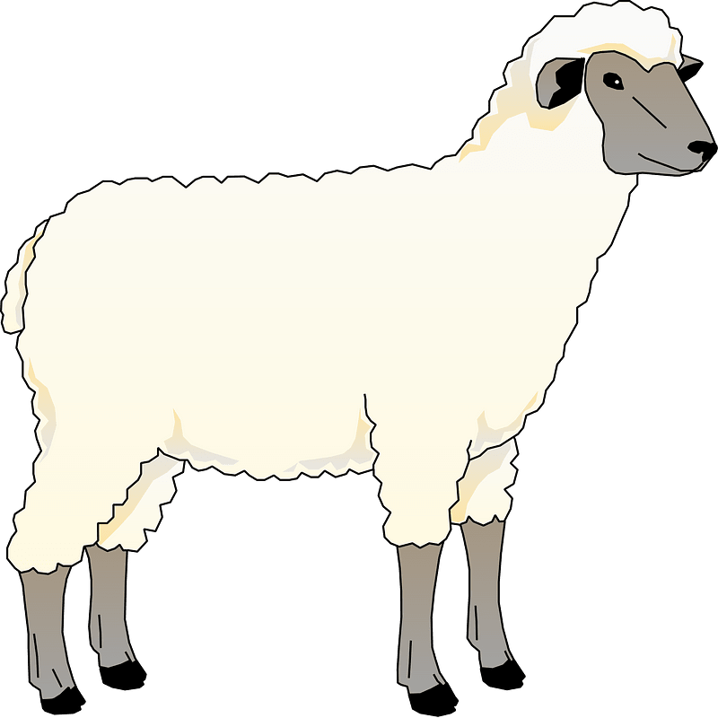


H…….se
Pl………
Sh……..p
C…….t


Your teacher:

الصف: الثالث البتدائي
المادة : اللغة اإلنجليزية

اختبارالفترة الاولى - الفصل الدراسي الاول

الادارة العامة لتعليم الرياض
المدرسة الثلاثون لتحفيظ القرأن .

Name / .....................................................
I- General Questions:
3
A- Match the questions in column (A) with the correct answers in column (B):
A | B
- What is your name ?  - Where do you live ?  - How old are you ? | ( ) I live in Dammam.  ( ) My name is Rose. ( ) I am 9 years old.

II- Controlled Writing:
Rearrange the following sentences :
2
- name / Pete / . / His / is ……………………………………………………….
- to / Nice / ! / you / meet …………………………………………………………

- Reading Short Sentence:
A- Put (
) or (
):

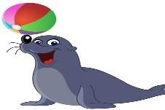
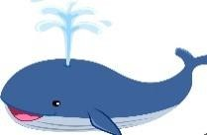
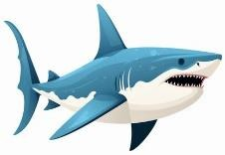
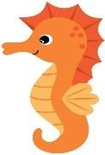
- The seal is cute 2- The seahorse is slow 3- The whale is small 4- The shark is scary
4

  - Grammar:
  - Choose :
3
    - I ( has - have ) a bicycle.
    - He ( has - have ) a computer.
    - The dolphin is ( fast – faster – fastest ) than the seahorse.

1 Turn on the page

  - Vocabulary:

      - Write the correct number under each picture:
4

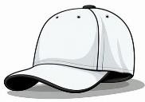
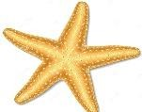
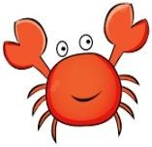
1- starfish
2- computer
3- cap
4- crab

( ) ( ) ( ) ( )

  - Orthography:
A) Choose the correct letter:
4
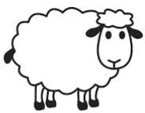
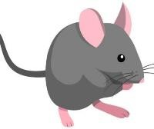
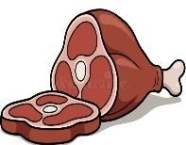

ou
ee
ay
ea

1- sh _ _ p 2 m _ _ se 3- m _ _ t 4- pl _ _

The End

Teacher: Bashayer Alhazzani

t

المملكة العربية السعودية

اختبار الوحدة الاولى

Name:………….……………………………… Class:…………………….
Q1-Match
What is your name? | I`m 9 years old
How old are you? | My name is Ahmed
Where do you live? | Nice to meet you too
Nice to meet you | I live in Jeddah

Q2-choose the correct answer:
1-This is my mother , ( her – his ) name is Amal.
2-She ( are – is ) from Saudi Arabia.
3-She ( have – has ) a red dress.
4-I ( have – has ) a car.
5-( whose - how )hat is this? It is mine

Q3-Unscramble the words:
 |  |  | 
erad | eshep | iep | arin
Tr.NajahEnglish
Name:……………………………….. Class:……………………….

المادة:لغة انجليزية
الفترة: الاولى
الصف: ثالث ابتدائي

المملكة العربية السعودية

15

Q1-Match
What is your name? | I`m 9 years old
How old are you? | My name is Ahmed
Where do you live? | yes, I do
Do you have a brother? | I live in Jeddah

4

Q2-choose the correct answer:
1-This is my mother , ( her – his ) name is Amal.
2-She ( are – is ) from Saudi Arabia.
3-as fat ( is – as ) a walrus.
4-She ( have – has ) a red dress.
5-a dolphin is ( cute – cuter ) than a seahorse.
6-( whose - how ) hat is this? It is mine

6

Q3-rearrange:
-to meet nice you.
………………………………………………………………..
1

T.Najah Aljuhani
GOOD LUCK
2

2
starfish - rain - dolphin - pie
Q5-Fill with:

h_ _ se | c_ _ t | m_ _ se | b_ _ t

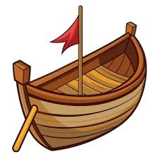
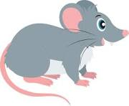
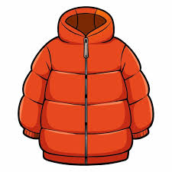

oa - ou
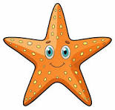
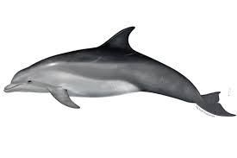
Q4-write the word under the picture:

…………………………… | ………………………….. | ………………………….. | ……………………………

Tr.NajahEnglish

