………
English Language
elementary Grade 4th
1st period Exam
…………….\20
الاسم: الصف:


……\ 4 marks

General questions

A.Answer the questions
My favorite outdoor place is a field. |  | What is the matter? | 1
You should clean the cut. |  | What is your favorite outdoor place? | 2
Yes, he could. |  | What should you do? | 3
He has a stomachache. |  | Coud he run fast ? | 4

Controlled Writing
……\ 1 marks
A-reorder.
1- could \ He \ photos\ take
a-He could take photos. b-photos take He could.

……\ 4 marks

Reading short sentence
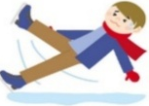 | 1- I tried to ice skate but it was very difficult. ( )
 | 2- There are some eggs in the nest. ( )
A-Put ( ✔ ) or ( X )
B. Choose the correct answer
c-ocean | b-island | a- desert | 1- Very dry land, usually with sand.
c-put on | b-cut | a-cry | 2- Something you do when you are sad.

……\ 4 marks

Grammar
A-Choose the correct answer.
c-s explores | b- explored | a-explore | 1- Faris decided to……..the cave.
c-hikes | b- hike | a-hiking | 2- Omar likes ……………in the hills.
c- climbing | b- climb | a- climbs | 3-Could they ………… the mountain?
c- shouting | b- shout | a- shouted | 4- I mustn't ……….in the hospital.

Vocabulary

A.Choose the correct word under each picture
……\ 5 marks

 |  |  | 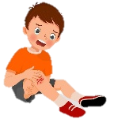 | 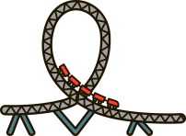
tiger | Take off | waterfall | hurt | roller coaster
snail | earache | Earth | x-ray | elbow
……\ 2 marks

Orthography
A. Fill in the missing letters
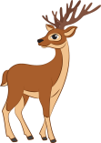

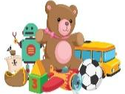
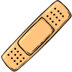

3- hi….l
( q– e – l )

( s – t - o)
1- dee….
( r – p - a )

2-..…oys
( p – t – k )

( s – t - o)
4- band ai…
( h – u - d )


Your teacher:

Your teacher …..:…………………………….

