10

اختبار مادة الإنجليزي للصف الأول ابتدائي الفصل الدراسي الثاني لعام
Name:-…………………………………..
A)- Choose the correct answer:
1- How old are you?
-I am 7 years old. –Fine thanks
2- count 1,2,…….
-5 3-
3-What shape is it?
- Triangle - Square
4- …..ish.
- F - Q.
B)-Complete : ( -i -h -j -f )
H .….. F …… I…… J……
C)-Circle the correct answer:
1- ( this - that ) is a book. 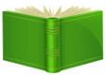
2- ( an - a ) apple.
3- ( circle – star )
D)-Color the shape: Red green

اختبار الفترة الثانية | المادة : اللغة الانجليزية | الصف : الأول | الدرجة النهائية
اسم الطالب / ة :.................................................. |  | الشعبة :....................

Choose the correct answer:

- How old are you ?

- I am 7 years old .
- Fine thanks .

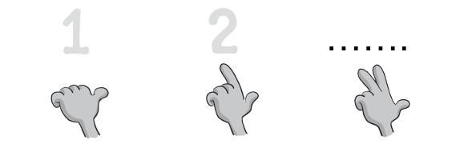
- Count 1 , 2 , …

- 5
- 3
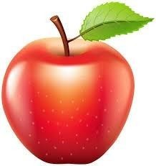
- It is …. Apple .

- an
- a

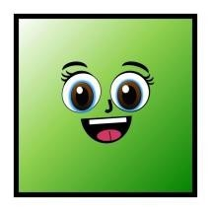
- What shape is it ? it is ……..

- Triangle
- Square

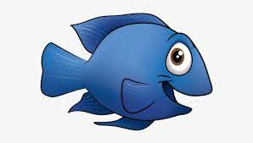
- …ish

- F
- X
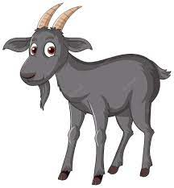
_____________________________________________________________
6- …oat
- X
- G
______________________________________________________________
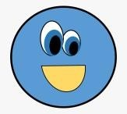
7- What shape is it ? it is ……..
- Circle

- Diamond

_____________________________________________________________
8- It is … book.
- an

- a
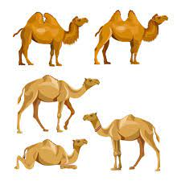
___________________________________________________________
9- ( 4 little , … little camels )
- 5

- 1
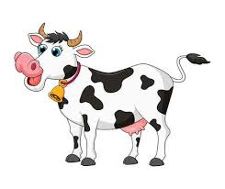
_______________________________________________________________
10- What color is it ? It is ……..
- Yellow and orange .

- Black and white .
1. Listen and write [ 34 ]
34 Do controlled writing such as supplying missing letters and words

Name…………………………………………………..
H
I
F
G
J

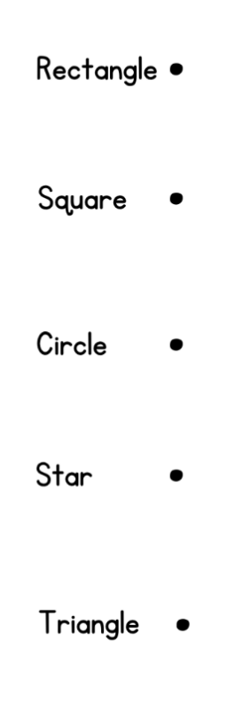
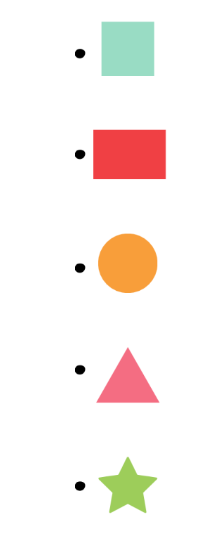
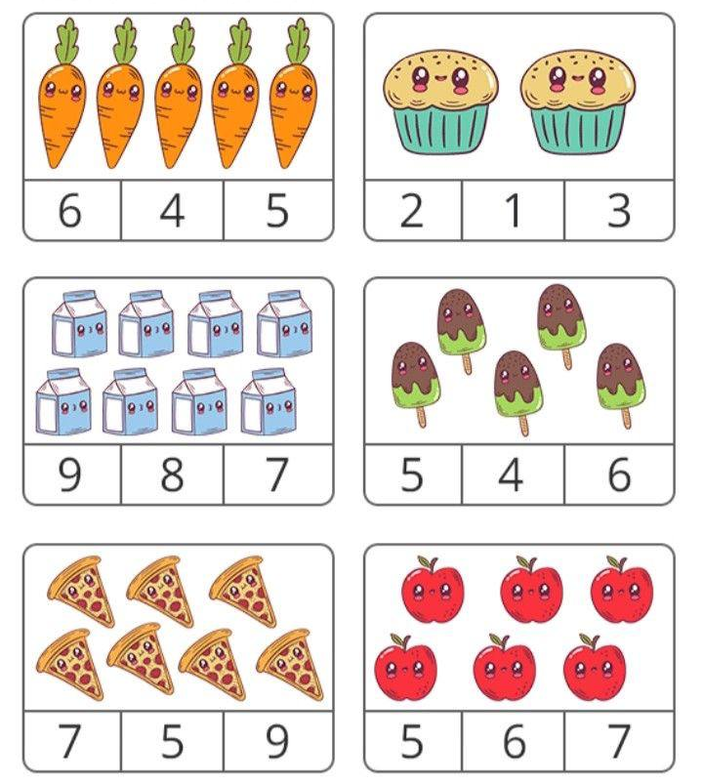
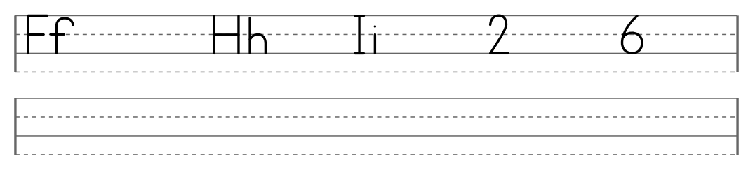
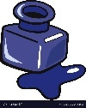
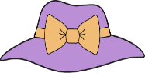
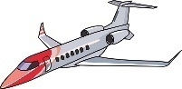
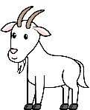
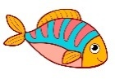
4. Match
5.

1.
2.
3.
4.

3. Choose. [ 21 ]
2. Copy.[ 29-30-31]
ET___
NK___
AT___
OAT___
ISH___
T. Dalal Alotaibi

