


التاريخ: / / هـ
الصف: ............... الابتدائي
الزمن: ساعة ونصف
المادة: اللغة الإنجليزية

أسئلة اختبار مادة اللغة الانجليزية للصف ال............. الابتدائي
للعام الدراسي هـ
الفصل الدراسي الأول
عدد الأوراق : 4

اسم الطالبة : ........................................................................
رقم الجلوس : .........................................................................
اليوم : ...............................................
التاريخ : .......... / ........... / 1447 هـ
الزمن : ...........................

 | Questions | Mark | Student's mark
Q1 | General Questions | 7
Q2 | Guided Composition | 7
Q3 | Reading Short Sentences | 7
Q4 | Grammar | 7
Q5 | Vocabulary | 7
Q6 | Orthography | 5
Total : |  | 40
المصححة : ...............................................................التوقيع :.....................................
المراجعة : ...............................................................التوقيع :.....................................

معلمة المادة :

......................................................



التاريخ: / / هـ
الصف: ............... الابتدائي
الزمن: ساعة ونصف
المادة: اللغة الإنجليزية

الدرجة رقماً |  | الدرجة كتابة |  | اسم المصحح | توقيعه | اسم المراجع | توقيعه
الدرجة رقماً | 40 | الدرجة كتابة | درجة فقط
اختبار اللغة الإنجليزية نهائي – الدورالاول – للصف ال.......... – الفصل الدراسي الاول هـ
اسم الطالب: ............................................ الفصل:
- General Questions:

7

- What is your favourite interest? |  | An architect.
- Who designs houses? |  | I need a key to get into a house.
- Who works in a hospital and helps sick people? |  | My favourite interest is drawing.
- What do you need to get into a house? |  | A doctor .
- What is your favourite dish? |  | We have 4 bedrooms .
- He is a flight attendant, isn’t he? |  | Yes, he is.
- How many bedrooms does your house have? |  | My favourite dish is pizza.
  - Match the questions with the correct answers:

- Controlled Writing:

7
        - Write a short paragraph about yourself.
Use the helping words to help you :
name – country – favourite food – hobby – future job
……………………………………..………………………………………………………………………………………………………………….
……………………………………..………………………………………………………………………………………………………………….
……………………………………..………………………………………………………………………………………………………………….
……………………………………..………………………………………………………………………………………………………………….
……………………………………..………………………………………………………………………………………………………………….
……………………………………..………………………………………………………………………………………………………………….
……………………………………..…………………………………………………………………………………………………………………
…………………………………………………………………………………………………………………………………………………………

B. Rearrange the words to form sentences:
    - shouldn’t – You – meals – skip
…………………………………………………………………………………………………………………………………………………….
    - going to – a book – I am – read
…………………………………………………………………………………………………………………………………………………….
C. Write the opposite :
1- Happy # ………………………….. | 2- Small #..............................

III. Reading Short Sentences:

7
  - Read the sentences then match them with the correct pictures:

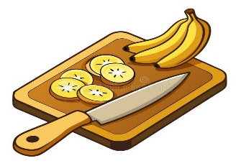 | 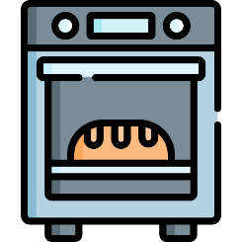 |  | 
a- Mix the ingredients.  b- Cut the bananas. | a-_It is an oven.  b-_It is a fridge. | a-He works in a factory.  b-He works in a hospital. | a-_He is a musician.  b-_He is a reporter.
  - Read and complete. Use the words in the box:

tidy – stage – honey - messy

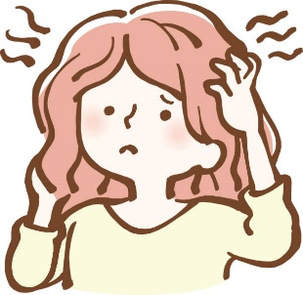  The woman has a  ……………………….. hair. |   Add ………………………  to make a sweet snack. |   Actors act on a ………………………..  .

- Grammar:
  - Choose the correct answer:

7
    - He (swim – swims – swam) in the ocean last summer.
    - You aren’t a doctor, (are you – aren’t you – you are)?
    - She (play – plays – played) board games on Thursdays.
    - This milk smells bad. You (had better – had better not) drink it.
    - It’s possible that we (may – might – are going to) study acting in the future.
    - He (is going to – will) play basketball tomorrow.
    - If you (eat – eats – eating) a good breakfast, you have lots of energy.

- Vocabulary:

7
  - Write the words under the correct pictures:
singer – cushion – fridge – untidy – Wi-Fi – screen – smell

 | 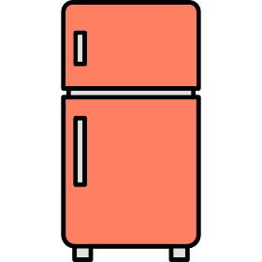 | 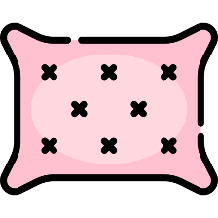 | 
 | 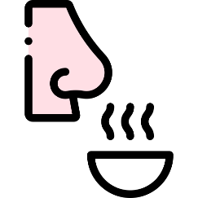 | 

5
- Orthography:
v – d – s – l – g
  - Fill in the missing letters:

 |  | 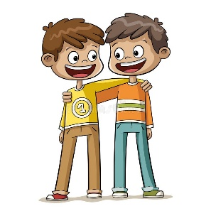 |   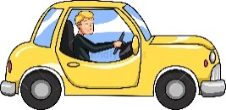 | 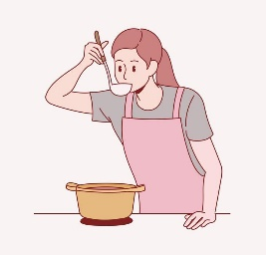
su__ar | she__f | frien__ly | dri__er | ta__te

المملكة العربية السعودية الصف: السادس الابتدائي
وزارة ...... الفصل الدراسي: الأول
........ ............................. العام الدراسي هـ
الزمن: ساعة ونصف
الاختبار النهائي لمادة اللغة الإنجليزية – الصف السادس الابتدائي – الفصل الدراسي الأول (الدور الأول) لعام هـ
عزيزتي الطالبة:
- استعيني بالله ثم اجيبي عن الأسئلة
- فضلا تأكدي من كتابة اسمك الرباعي ورقم الجلوس
- الإجابة باللون الأزرق فقط

اسم الطالبة رباعيا
رقم الجلوس: |  | الصف: السادس الابتدائي | المادة: اللغة الإنجليزية
اليوم: | التاريخ: / 7 / هـ

المدققة وتوقيعها | المراجعة وتوقيعها | المصححة وتوقيعها | الدرجة كتابة | الدرجة رقما | السؤال
 |  |  | فقط |  | General  Questions
 |  |  | فقط |  | Guided  Composition
 |  |  | فقط |  | Reading  Short Sentence
 |  |  | فقط |  | Grammar
 |  |  | فقط |  | Vocabulary
 |  |  | فقط |  | Orthography
 |  |  | فقط | 40 | المجموع

Kingdom of Saudi Arabia 6th Elementary Grade
Ministry ................... Time: An hour and a half
……….. Elementary School Number of papers: 3 . Final Exam – First Term – AH
- General Questions:
/ 7
  - Match the questions with the correct answers:
A |  | B
1. How many classes do you have on Tuesday? |  | Vegetables &fruit, starches and proteins.
2. Which activity do you not want to try? Why? |  | I work in an office.
3. What materials will the builders use? |  | I have six classes on Tuesday.
4. He is a flight attendant, isn’t he? |  | Concrete, glass, and steel.
5. Where do you work? |  | My favourite dish is pizza.
6. What are the three most important food types? |  | Voyaging because it is boring.
7. What is your favourite dish? |  | Yes, he is.
/ 7
- Guided Composition:
  - Complete the paragraph about Your Dream Job. Use the words from the box.
money – hospital – skills – study – sick – doctor – feel
My Dream Job
I want to be a ………….... I will work in a ………….... I need to ………… well at school. I need good ………… like listening carefully and being kind. I like this job because I help ………… people and make them …………. better. I will earn a lot of …………



- Reading Short Sentences:
/ 7
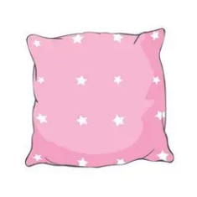
  - Read the sentences then match them with the correct pictures:
 |  | 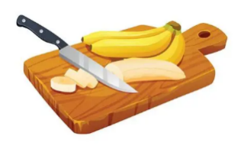 |  | 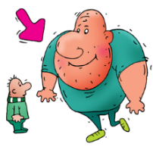
a-_A waiter serves food.  b-_An actor acts in films. | a-_It is a fridge.  b-_It is a cushion. | a- Mix the ingredients.  b- Cut the bananas. | a- It’s a rainbow.  b- It’s a mountain. | a-_He is upset.  b-_He is enormous.

  - Look at the picture and text and choose the best option.
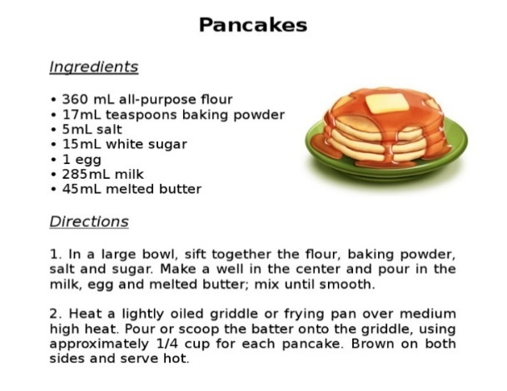
    - This text is:
      - an e-mail.
      - a recipe.
      - a dialogue.

    - The text is about:
a- sugar-free pancake.
b- homemade pancake.
c- the best pancake maker.

- Grammar:
/ 7
  - Choose the correct answer:
    - I had better (washing – washed – wash) my hands before I start.
    - She (am going to – is going to – are going to) be a novelist.
    - They can’t be businessmen, (can they – can’t they – they can)?
    - I will (order – orders – ordered) a pizza.
    - He (swim – swims – swam) in the ocean last summer.
    - He is the (tall – taller – tallest) student.
    - (How many – How long – How much) was your vacation?

- Vocabulary:
/ 7
  - Write the words under the correct pictures:
months – stairs – singer – horrible – pour
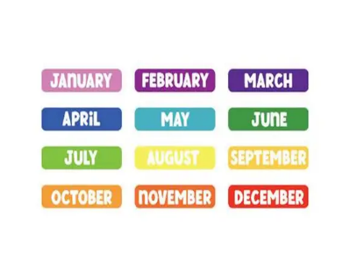
 |  |  | 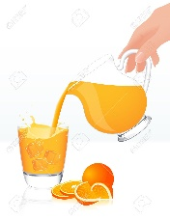 | 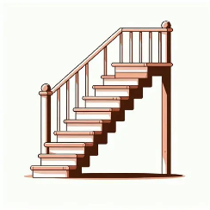

  - Fill in the blanks with the words from the box.
dairy – tidy – measurements
1- …………….. : clean and organized.
2- …………..… : These are numbers that express the size of a room.

- Orthography:
/ 5
  - Choose the correct missing letters:
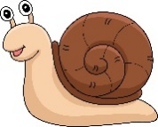  s__ail |  | 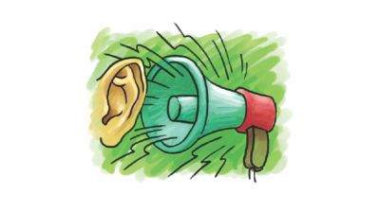  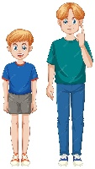  t__ll |  | noi__y |  |   pr__ze |  | 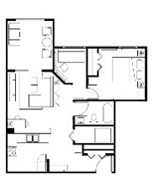  la__out
m | n | a | o | s | z | a | i | y | u
  she__f |  | dri__er |  | 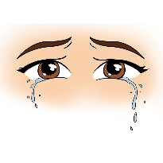  tea__s |  | 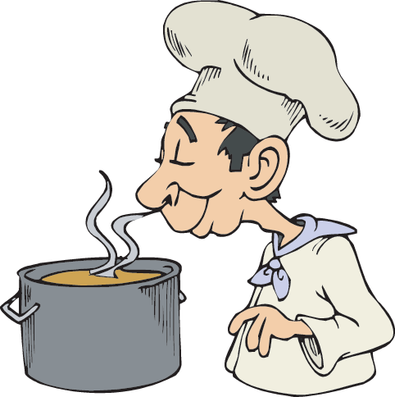  s__ell |  | 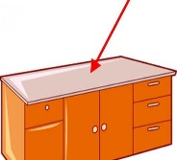  coun__ertop
l | k | f | v | r | n | h | m | t | d

END OF QUESTIONS
BEST OF LUCK
Ms. Tahani AlGhamdi

التاريخ: / /
الصف: السادس الابتدائي
الزمن: ساعة ونصف
المادة: اللغة الإنجليزية

الدرجة رقماً |  | الدرجة كتابة |  | اسم المصحح | توقيعه | اسم المراجع | توقيعه
الدرجة رقماً | 40 | الدرجة كتابة | درجة فقط
اختبار اللغة الإنجليزية نهائي – الدور الاول – للصف السادس – الفصل الدراسي الاول هـ
اسم الطالب: ............................................ الفصل:

7
- General Questions:
- What is your favourite interest? |  | An architect.
- Who designs houses? |  | Voyaging because it is boring.
- What jobs do people in your community do? |  | My favourite interest is playing the guitar.
- Which activity do you not want to try? Why? |  | Teachers, doctors and engineers.
- What is your favorite dish? |  | Eat fruit & vegetables and drink water.
- He is a flight attendant, isn’t he? |  | Yes, he is.
- How can you improve your eating habits? |  | My favorite dish is pizza.
  - Match the questions with the correct answers:

- Controlled Writing:

7
B- Write the opposite of the following words:
1- happy ≠ ………………. 2- small ≠ ≠ ………………. 3- rich ≠ ……………… 4- good ≠ ……………..

  - Rearrange the words to form sentences:
    - shouldn’t – You – meals – skip
……………………………………………..
    - going to – a book – I am – read
……………………………………………..
    - works – My dad – a factory – in
……………………………………………..

- Reading Short Sentence:

7
  - Read the sentences then match them with the correct pictures:

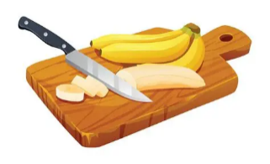 | 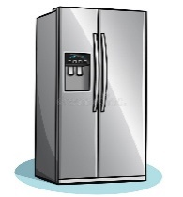 |  | 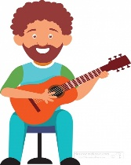
a- Mix the ingredients.  b- Cut the bananas. | a-_It is an oven.  b-_It is a fridge. | a-He works in a factory.  b-He works in an office. | a-_He is a musician.  b-_He is a reporter.
  - Read and complete. Use the words in the box:
tidy – stage – honey - messy

  The woman has a  ………… hair. | 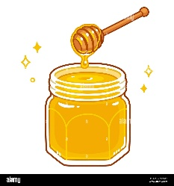  Add ……………………  to make a sweet snack. |   Actors act on a ……………….

- Grammar:
  - Choose the correct answer:

7
    - He (swim – swims – swam) in the ocean last summer.
    - You aren’t a doctor, (are you – aren’t you – you are)?
    - She (play – plays – played) board games on Thursdays.
    - This milk smells bad. You (had better – had better not) drink it.
    - It’s possible that we (may – might – are going to) study acting in the future.
    - He (is going to – will) play basketball tomorrow.
    - If you (eat – eats – eating) a good breakfast, you have lots of energy.

- Vocabulary:

7
  - Write the words under the correct pictures:
singer – measure – gallery – untidy – Wi-Fi – stadium – smell

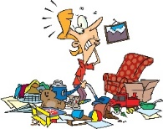 |  | 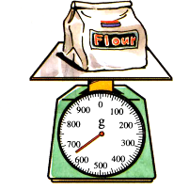 |  |  |  | 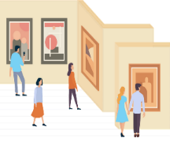

- Orthography:
v – d – s – l – g

5
  - Fill in the missing letters:

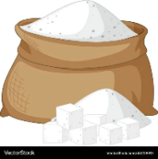 |  | 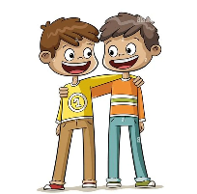 |  | 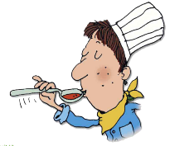
su__ar | she__f | frien__ly | dri__er | ta__te

المملكة العربية السعودية |  | Omar AlQurashi |  |  | المادة |  | لغة إنجليزية
 |  |  |  |  | الصف |  | السادس
 |  |  |  |  | الزمن |  | ساعتان
أسئلة اختبار نهاية الفترة الدراسية الأولى (الدور الأول) للعام هـ
اسم الطالب/ـة |  |  | اللجنة |  |  | رقم الجلوس

السؤال |  |  | السؤال الأول | السؤال الثاني | السؤال الثالث | السؤال الرابع | السؤال الخامس | المجموع | الدرجة الكلية
الدرجة | رقما
الدرجة | كتابة |  |  |  |  |  |  |  | 40
المصحح/ـة
المراجع/ـة
المدقق/ـة

14درجة
Q1)- A - Choose the correct answer ;
calling | call | .5- I will ___ him now | many | long | 1– How__ is the break ?
turning | turn | 6-We should _ the oven on. | much | many | 2-How _ boys are there ?
is he | isn't he | 7-He isn't a doctor ,__ ? | went | go | 3- He didn't ___ to Jeddah.
 |  |  | gone | going | 4- I am ___ to be a teacher.

B - Choose the correct answer:
1 – What are you going to be when you grow up ? A . an artist B . gallery
2 – Tidy means A . messy B . organized
3 – Who fixes cars ? A . mechanic B . pilot

4 – Which country will host the world cup 2034 ? A . Saudi Arabia B . Oman

5 – Someone is expert A. receptionist B. specialist
6 – Why is breakfast important ? A . gives you energy B. helps you sleep
7- What a balanced diet ? A . eat everything B. eat a bit of everything

Q2-) A- Fill in the missing letters :

12درجة
 |  |  | 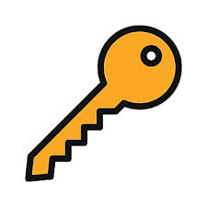 | 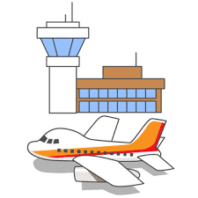
fa __ tory | sta __ e | act __ r | k __ y | air __ ort
c | g | o | e | p
k | j | u | i | b

_________________________________________________________________
B-) Read and say if the sentences are True ( ) or False ( X ) ;

X |  | . 5- A photographer takes pictures | X |  | 1– A waiter fix cars .
X |  | 6- You shouldn't use too much sugar. | X |  | 2- A pilot works at airport.
X |  | 7- Who takes a tour is an artist. | X |  | 3- Journalist reports news.
 |  |  | X |  | 4- Actors act on a factory.

14 درجة
Q3)-A- Choose the correct word :
 | 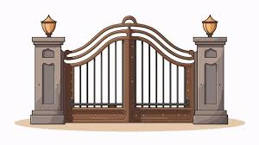 |  | 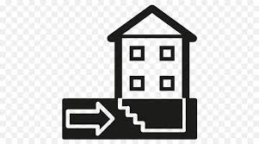 |  |  | 
factory  wi-fi | window  gate | doctor  pilot | basement  entrance | artist  waiter | screen  shelf | noisy  lucky

Use the following words to complete the paragraph about My house . B-)

very | Living room | big | garden | clean | like | kitchen

My house is …………………… and ……………..……… . It has a ………………………………… , 4 bedrooms , 5 bathrooms and a ……………………… . There is a …………………… in front of my house . I ………………… my house …………………much .
انتهت الأسئلة .. تمنياتي لكم بالتوفيق والنجاح
معلم المادة:
عمر القرشي

40

اختبار نهاية الفصل الأول( الدور الأول)
للعام الدراسي
المادة /اللغة الانجليزية
الصف :سادس (.......)
زمن الإجابة / ساعة ونصف
التاريخ : 12/7/1443 هـ

المملكة العربية السعودية

الدرجة كتابة :

اسم الطالب ……………………………………………………………………….……………………………………………رقم الجلوس …………………………

Circle the correct answer: ضع دائرة حول الإجابة الصحيحة
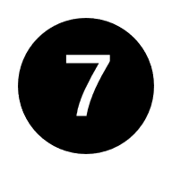
1- What is your friend’s favorite interest? a night b swimming
2-When do you practice your interest? a home b in the morning
3- What does your ideal home look like? a small and modern b sleep
4- What’s your favorite job? a car b a journalist
5-What skills do you need for this job? a drink b report news
6- What’s in your favorite food? a yoghurt b T-shirt
7- potatoes, pasta, and rice are …. a starches b vegetables

Complete the composition using the words in the box: اكمل التعبير
ضع الكلمات في فراغات التعبير

1 every week. 2 school. 3 football. 4 Messi. 5 friends. 6 skilled. 7 Ronaldo.

My favorite activity is ……………………..………………..I practice it ……………………………………………….…..
at ……………………..……………….. with my …………..…………………………... My favorite players are
……………………………………. and ……………………..…………..…. because they are very …………………………………...

Read the sentence, then choose the correct answer: اقرأ الجملة ثم اختر الإجابة الصحيحة

1. Fridays are horror movie nights. 4. Pilots fly planes. 7. Proteins make you strong.
What kind of movies on Fridays? Who flies the planes? What makes you strong?
a Horror. a Driver a Proteins
b Cartoon. b Pilots b Candies
2. Origami is very relaxing. 5. Mutabbaq is common in KSA.
How is origami? Where is Mutabbaq common?
a Relaxing a Egypt
b Tiring b Saudi

3 Hassan will be a photographer. 6. Wash hands before you begin.
What will Hassan be? What should you wash?
a Photographer a Hands
b Actor b Face
اقلب الصفحة

Choose the correct words:اختر الإجابة الصحيحة
- He ……… fishing. a like b likes
- They …………… the match yesterday. a watch b watched
- I just ate lunch. I……… eat. a will b won’t
- We are… visit granny next week. a going to b will
- They aren’t doctors, ………… they? a are b aren’t.
- She is hungry,…………. she? a isn’t b is
- You …… get your ingredients. a should b had better not

Match the words to the correct pictures: ضع رقم الكلمة تحت الصورة الصحيحة
1 cut 2 roll 3 airport 4 waiter 5 Wi-Fi 6 fridge 7 unkind

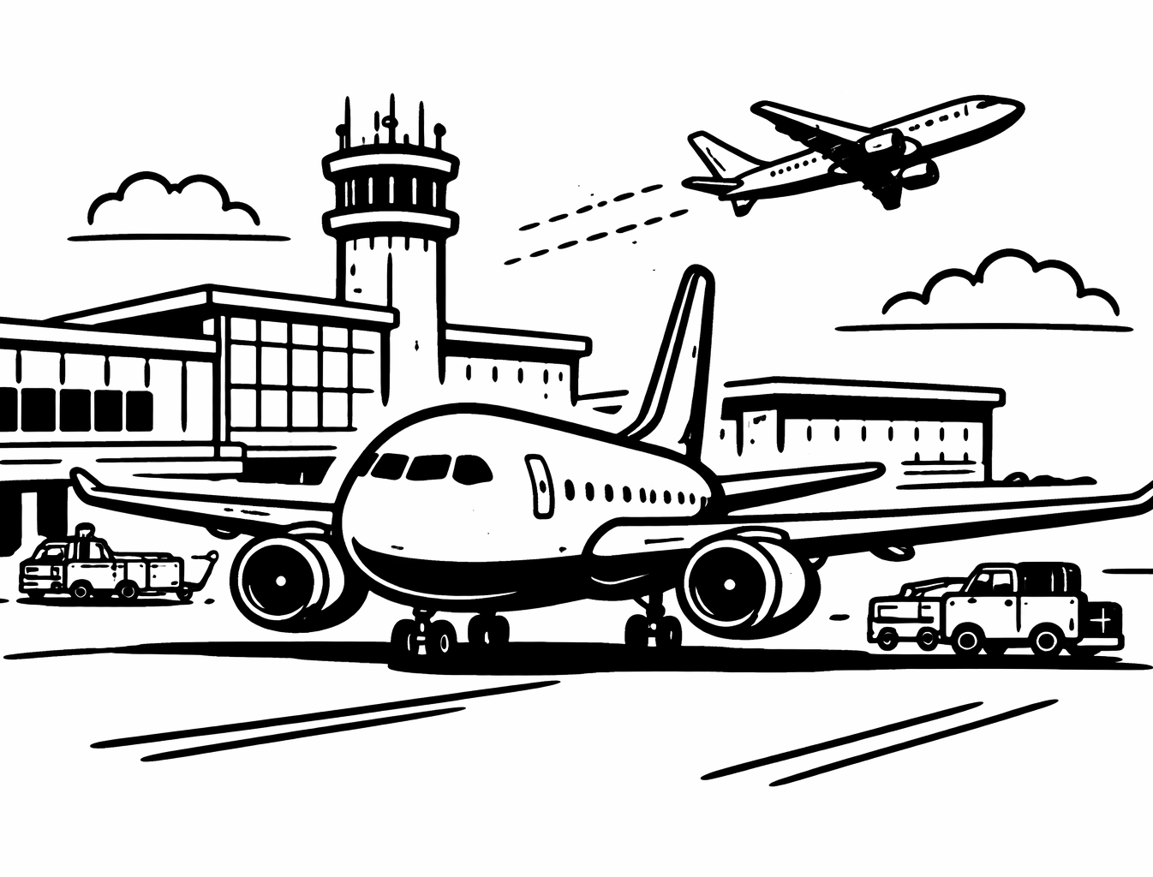
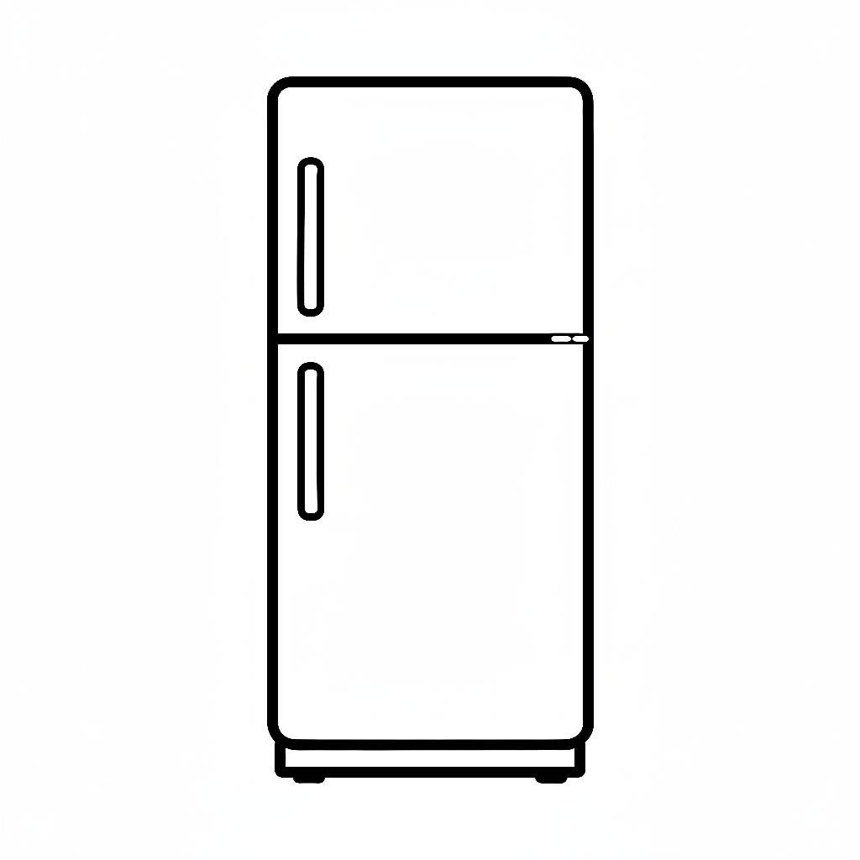
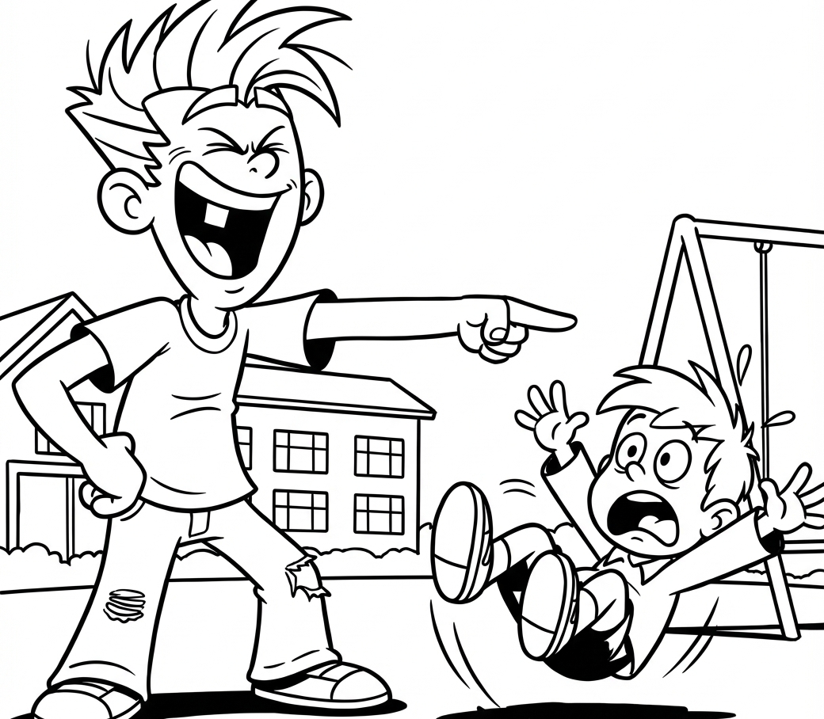
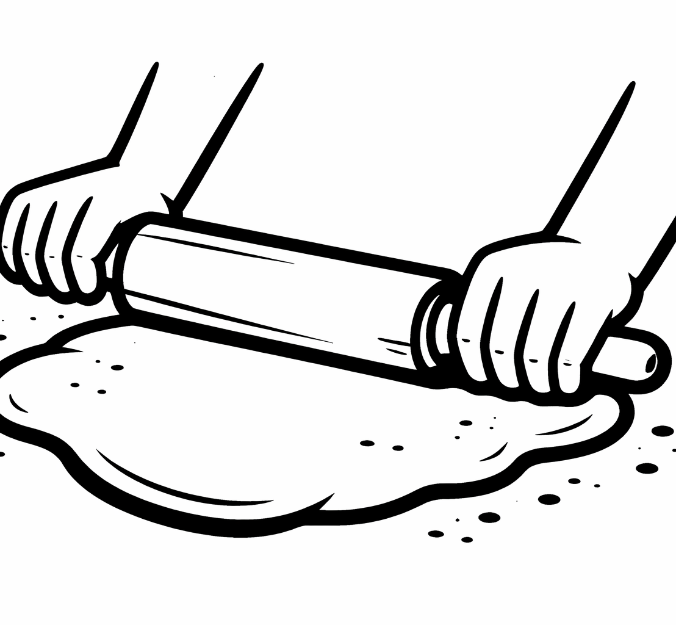
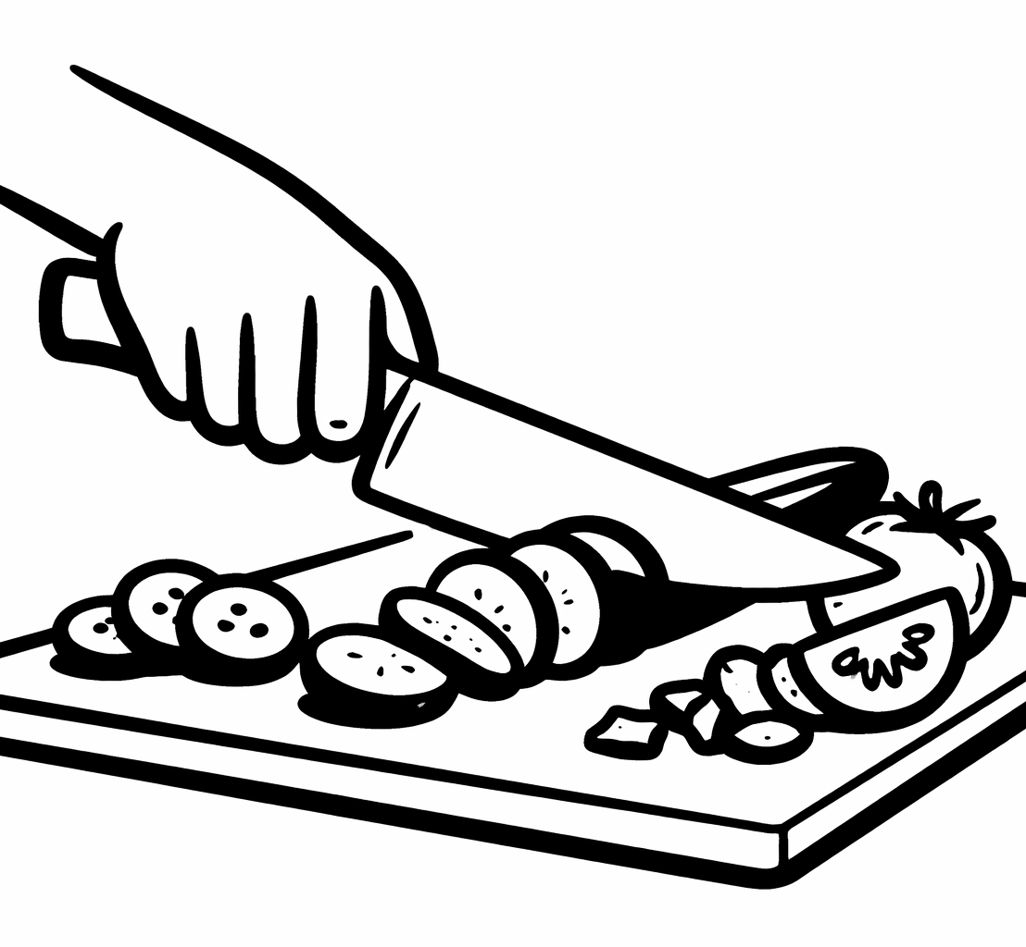
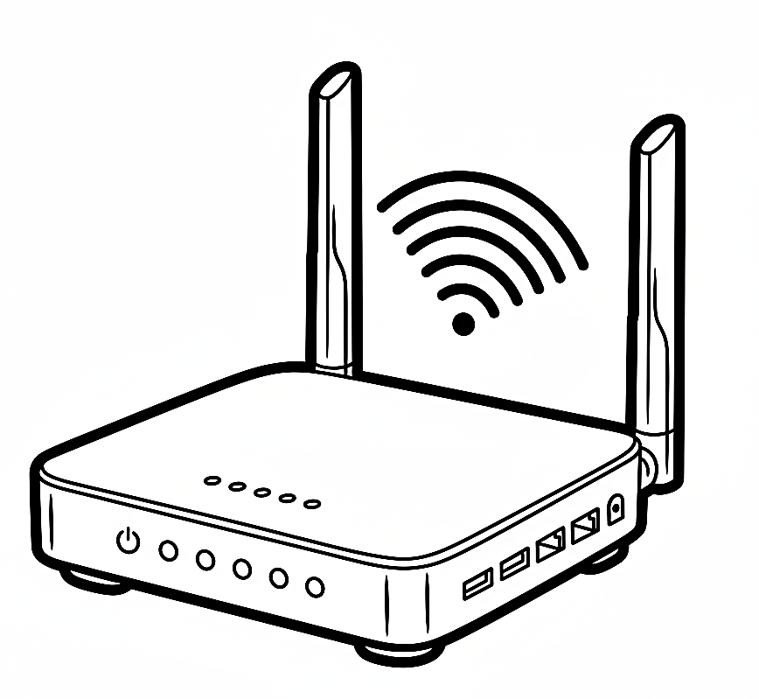

ضع دائرة حول الحرف المفقود Circle the missing letter:

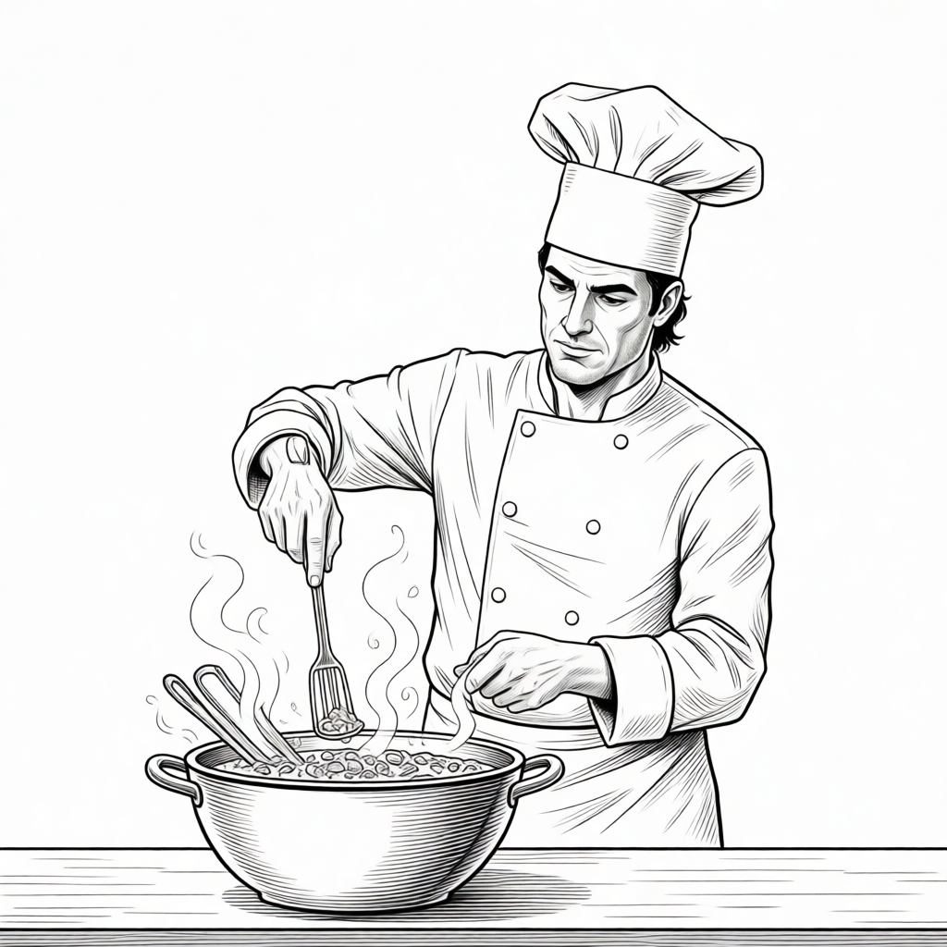  sti_  y  r |   ne_s  t  w | po_r  u  p | 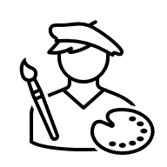  arti_t  s  k |     m_x  i  f
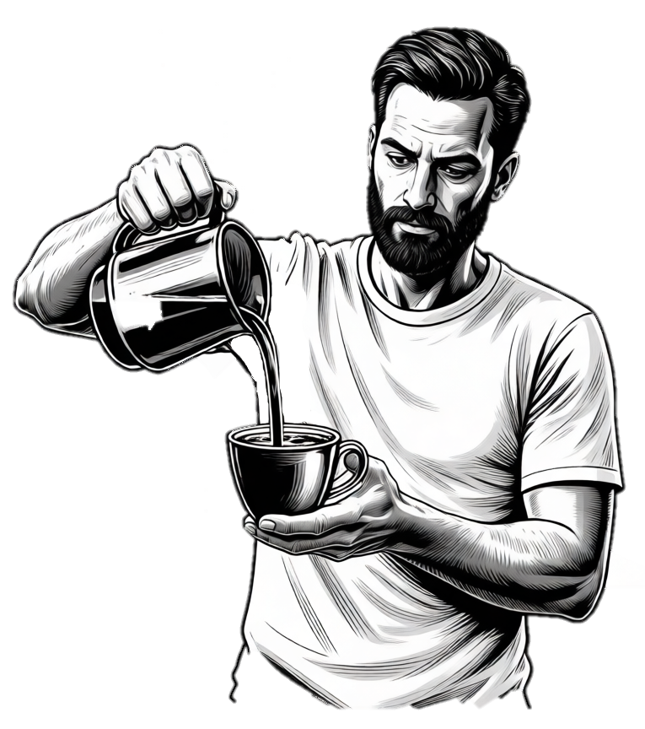
انتهت الأسئلة

أ............................................
المملكة العربية السعودية اسم المادة: اللغة الانجليزية
الصف: السادس الابتدائي
الزمن: ساعة ونصف

أسئلة اختبار مادة اللغة الإنجليزية للصف السادس الابتدائي
الفصل الدراسي (الأول) للعام الدراسي

اسم الطالب: ------------------------------------------- رقم الجلوس: ------------ الصف: --------

Total  Written | 6  Orthography | 5  Vocabulary |  | 4  Grammar | 3  Reading Short Sent. | 2  Guided Composition |  | 1  General Questions | Q. NO.
 |  |  |  |  |  |  |  |  | Mark Given
40 | 5 | 7 |  | 7 | 7 | 7 |  | 7 | Mark
Checker: |  |  | Revisor: |  |  |  | Corrector:

ABOKHALEDAMER
0557325813

7
I- General Questions:(7M)
A) Answer the following questions:
1. What is the best day for you? ------------------------------------------------------
2. What word describes a loud place? ----------------------------------------------
3. Who designs houses? ----------------------------------------------------------------

B) Match questions in "A" with their answers in "B":
1. What did you eat? A. They work in a gallery.
2. Did you play yesterday? B. I ate mutabbaq.
3. Where do artists work? C. Yes, I did.
4. Where do you live? D. I live in Najran.
II- Guided Composition:(7M)

7
Write a paragraph about your "Future Plans"
You may use these guided words: future – doctor – sick – better – study – dream
-------------------------------------------
----------------------------------------------------------------------------------------------------------------------------------------------------------------------------------------------------------------------------------------------------------------------------------------------------------------------------------------------------------------------------------------------------------------------------------------------------------------------------------------------------------------------------------------------------------------------------------------------------------------------------------------------------------------------------------------------------------------------------------------------------------------------

7
III- Reading Short Sentence:(7M)

A. Number the action sentence with the correct picture:
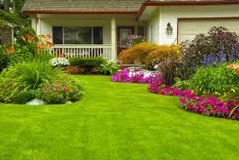
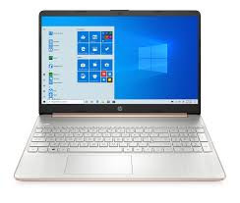
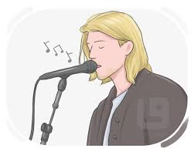
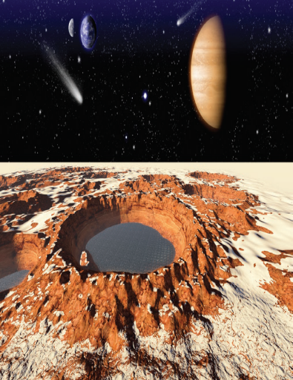
1. This is the front yard.
2. Mars is a near planet.
3. She sings in concerts.
4. My laptop is expensive. ( ) ( ) ( ) ( )

B. Choose the correct answer:
1. The best day of the week is -------------- (June – December – Thursday)
2. He drives cars. He is a ---------------. (engineer – screen – driver)
3. We bake pancakes in the---------------. (fridge – oven – car)

7
IV- Grammar:(7M)

A: Choose the correct answer:
1. He is the (tall – taller – tallest) student.
2. Where did you play (every day – yesterday – now)?
3. You (had better – had better not – shouldn't) study hard.
4. If you want to eat a sweet snack, (added – adding – add) sugar.

B: Do as shown between brackets:
1. I am going to sleep at Ali's house tonight. (Use: not)
-------------------------------------------------------------------------------------------
2. It will rain tomorrow. (Make Yes/No Question)
-------------------------------------------------------------------------------------------
2. We don't like pizza, ------------------------? (Add a Question Tag)
-------------------------------------------------------------------------------------------
V- Vocabulary:(7M)

7

A: Write the correct word under the correct picture:
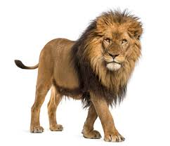
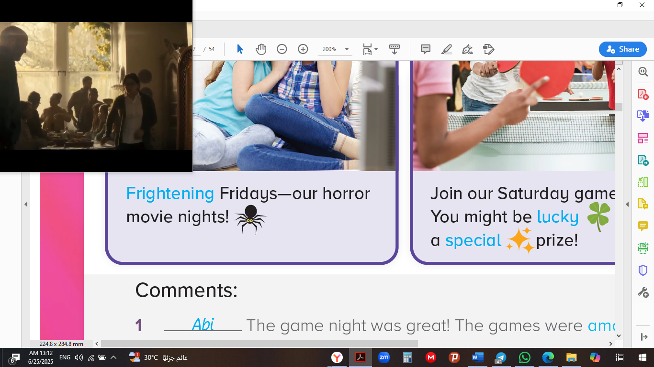
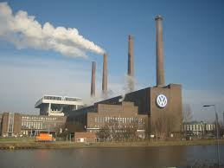
Wi-Fi – frightening – factory – lion
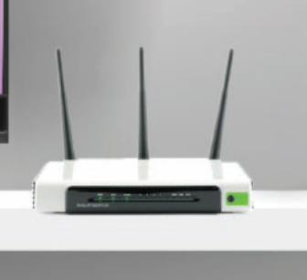

---------------------- ------------------------- ------------------------ -----------------------

B. Choose the correct answer:
1. This man doesn't look after himself. He looks (messy – tidy – clean)
2. A (cyclist – receptionist – journalist) works in the hotel reception.
3. Be careful. The (ice cream – salad – pan) is very hot.

7
VI- Orthography:(5M)
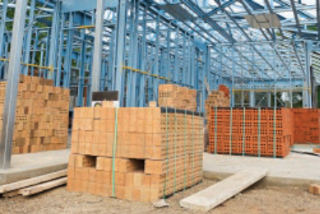
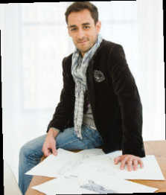
A: Fill in with the missing letters:

1. He is a famous clothes de__igner. 2. We need materia__s to build houses.

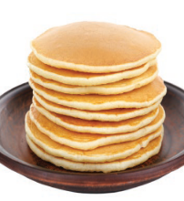
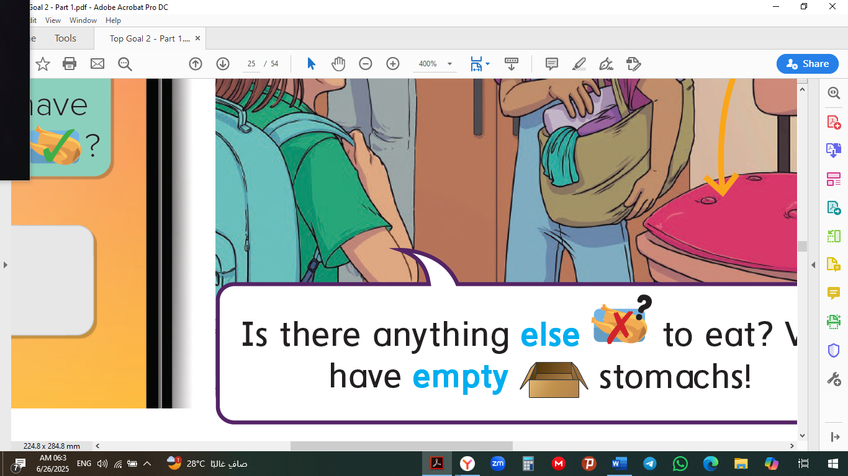
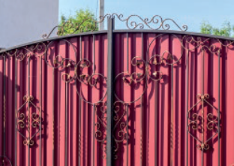
B. Unscramble the letters to form a word:

1. epymt 2. capanke 3. egta
--------------- --------------- -------------
End of Questions
ABOKHALEDAMER
0557325813

https://t.me/abokhaledamer
Top Goal - YouTube

