المملكة العربية السعودية مادة اللغة الإنجليزية
وزارة الصف : الثاني الابتدائي
إدارة بـ ................... اختبار تشخيصي ( قبلي)
........................... الدرجة : ........... \ 20

الأسـم : …………………………موقع حلول كتبي………………… الصـف : ………………………….

A- Match
My name is Ahmad. |  | what is your name ? | 1
Nice to meet you, too. |  | Good bye. | 2
Good bye. |  | What’s this color? | 3
Hi |  | Nice to meet you. | 4
It's blue. |  | hello | 5

B- Choose the correct answer
1- This is ( a – an - are ) apple.
2-How are you? – ( I'm fine - good morning – welcome)
3- That is ( a – is - an ) flower.
4-What shape is it ? it is…….
5- What color is it ?
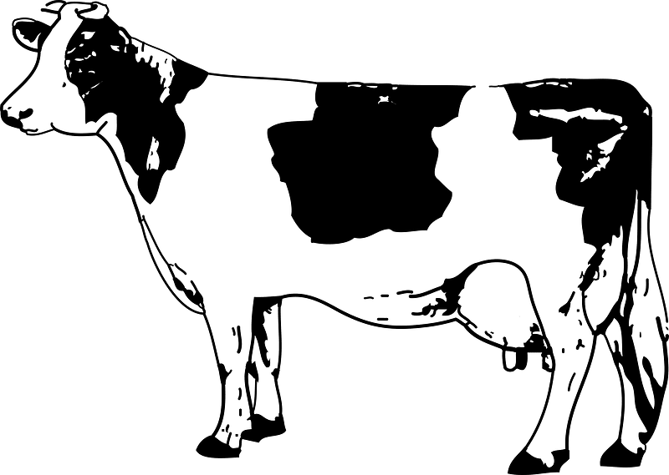
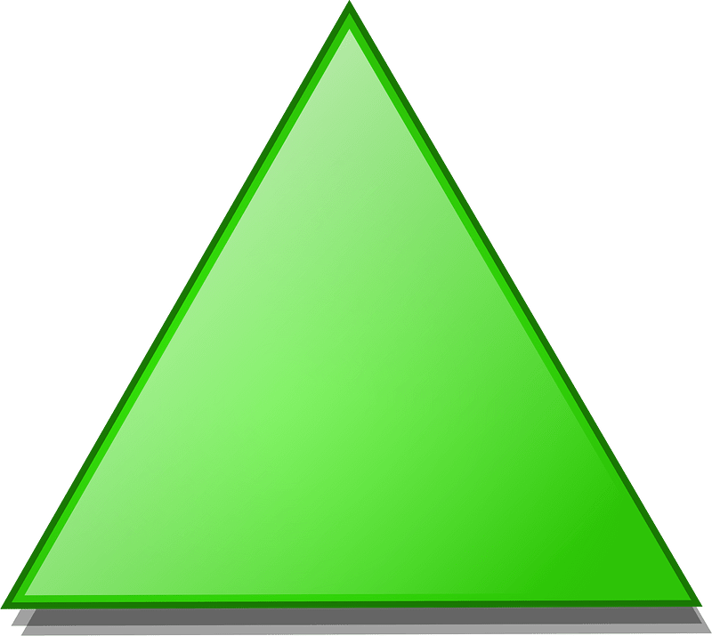
a- it's black and white.
b- it's red and pink.

a- Triangle
b- Square

C- Complete.

1 , 2 , …….… , ………, 5 , 6 , 7 , 8 , ………. , 10.
2- A , B , ……… , D , E , …….. , ……….. , H

D- Complete the missing letters
f d g b




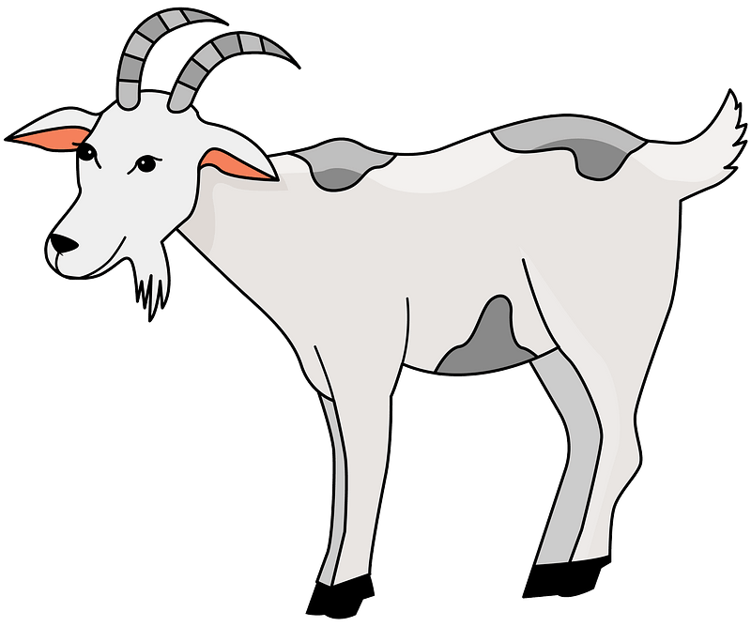

1-….ish 2- ……oat 3- …..ad 4- ……ear

Good luck
Your Teacher ………………..

Name:………………………… |  | Class:
اختبار تشخيصي للصف الثاني ابتدائي - WE CAN

1- Listen and circle:
 | 7 | 8 | 9
 | brother | sister | Dad
 | a | e | o
 | head | hand | Nose
 | board | bag | Pencil
2- - Listen and number:
 | 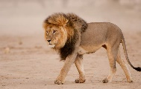 |  | 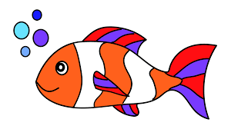
3- Match:

 | Hi | Good morning
 | Good morning | Hi
 | Goodbye | Goodbye
 | Hello | Fine thanks
 | How are you ? | Hello
4- Find and circle:
7 | 7 | 8 | 8 | 7
c | A | c | A | a
E | E | a | a | e
g | ل | O | O | o
a | a | B | B | b

5-Complete:
10 |  | 8 |  |  | 5 | 4 |  |  | 1
6-Look and write:
( baby - bag - Dad - hand - book )
 |  |  |  | 
…………….. | …………….. | …………….. | ……………. | ……………..
7- Count and write:
 + =
 + =
8- Copy:
3
a a a
t t t
b b b


9- Match:
2





5

